Report 1: Establish a baseline survey for farmers in the 12 villages, emphasising agricultural crops, practices, and household characteristics.

Report by Dr. Brian Cook, Dr. Nicholas Read, et al.

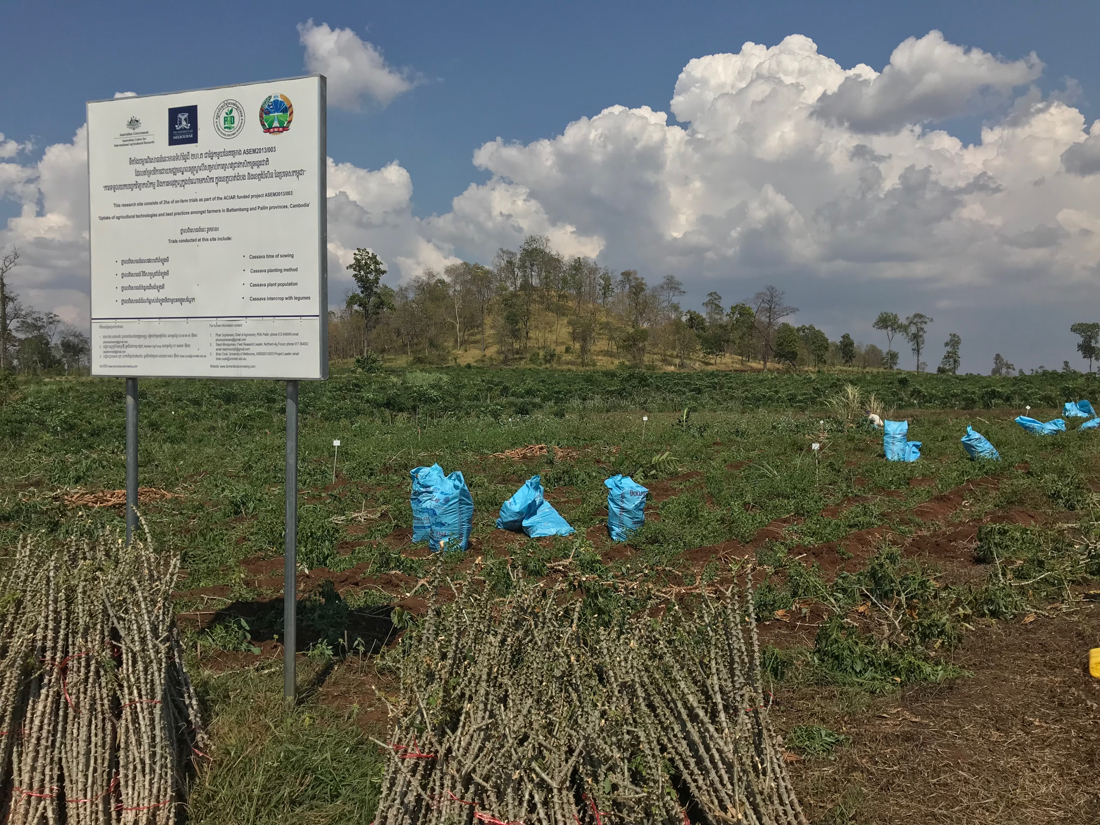
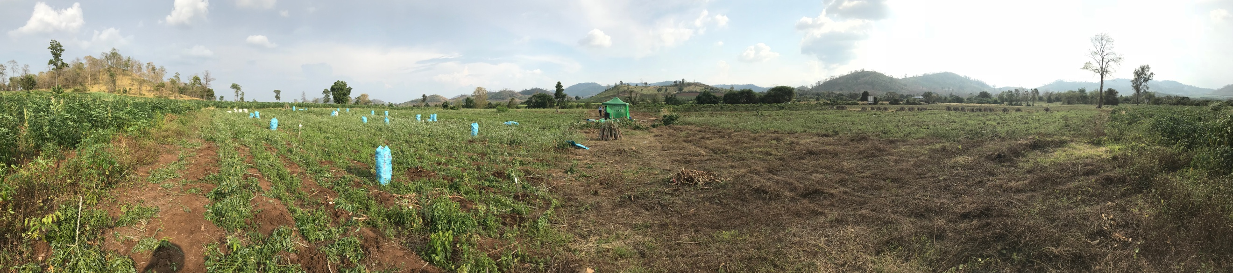
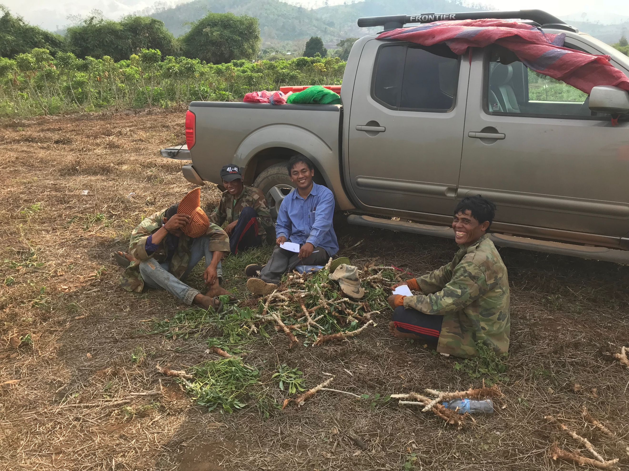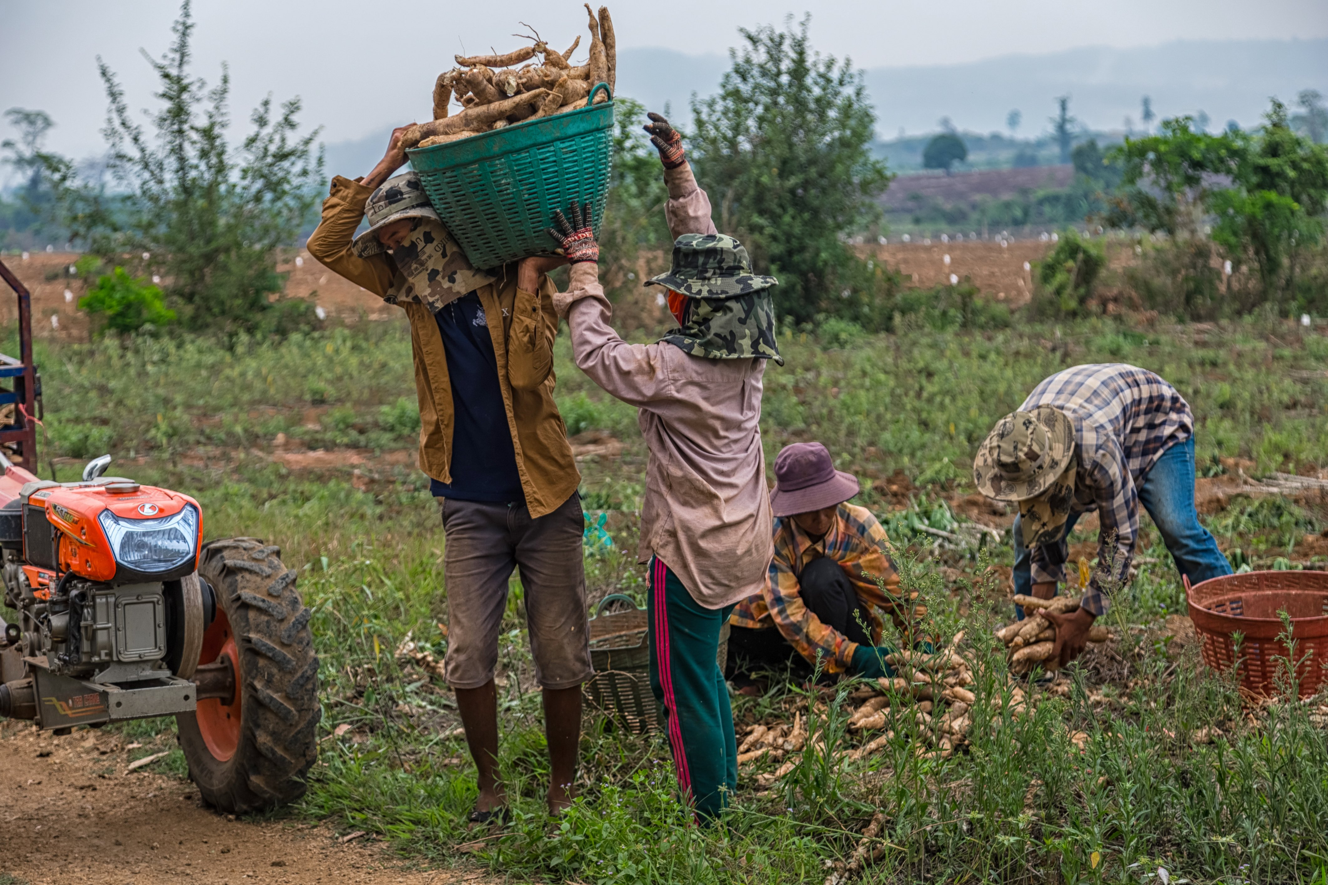
Report 1: Establish a baseline survey for farmers in the 12 villages, emphasising agricultural crops, practices, and household characteristics. 1
Background 4
Methodology 5
Data Analysis 6
Findings 6
Farm household profile: 7
Land 8
Labour 9
Income 10
Cassava 13
Loans 14
Fruit tree crops 15
Pest and Disease 18
Gender 20
Future outlook (Problem-Solution Pathways) 22
What one change would most improve your life? 22
How might this change happen? 22
Who has the power to make this change? 23
Conclusion 23
Key findings 23
References 25

Figure 1: FAO Stat data (http://www.factfish.com) 4
Figure 2: Cassava Quantity in Cambodia (http://www.factfish.com) 4
Figure 3:ACIAR Samlout Case Study: Village Locations 6
Figure 4 Figure 5: 7
Figure 6: Total land area with colour-coding to distinguish owned, rented, primary, and with/out title (i.e., deed) 8
Figure 7: total land by ownership Figure 8: total land by area 9
Figure 9: Percentage of annual labour of HoH in agriculture 9
Figure 10: number of family in Agriculture Figure 11: histogram of family members in Agriculture 10
Figure 12: far right findings because N/A chosen for some incomes. 11
Figure 13 : ordered income inclusive on/off farm Figure 14: differentiated by land area 11
Figure 15: extreme variability of income by land managed 12
Figure 16: 12
Figure 17 13
Figure 18: income by KG 14
Figure 19:Considerations affecting cassava production 14
Figure 20: responses from farmers on the manageability of their debt 15
Figure 21: loans by area– and manageability Figure 22: value of loans by area – and manageability 15
Figure 23: Stated use of loan 15
Figure 24: fruit trees crops grown in Northwest Cambodia 16
Figure 25: Two trends? Of Trees production and income Figure 26: non-zero fruit tree profits 16
Figure 27: Popularity of tree types 17
Figure 28 Figure 29 17
Figure 30: those with more trees tend to have more land and more secure land tenure 18
Figure 31: observation of P&D on farm 18
Figure 32: attributed losses to cassava by pest and disease 19
Figure 33 : who is responsible for P&D Figure 34: differences in Female-headed households? 20
Figure 35: frequency of checking for P&D 20
Figure 36: Household size by gender of HoH (note two tails – unknown causes) 21
Figure 37: Income by gender, including on/off farm experiences – all suggest female HoH receive less income 21
Figure 38: Land and are by gender 22
Figure 39: who can implement change? 24
Figure 39: who can implement change? 24

Background
There is relatively little reliable information available concerning cassava farmers from the Northwest of Cambodia. This gap is especially pronounced in the context of perception-based data linked with household characteristics and the desires of farming households. Even less common are statistically representative findings that, while not perfect, allow for cautious extrapolation from the sampled farmer households. Like everywhere, farmers are foundational to the agricultural system in Cambodia, including efforts to influence decision making in the context of crops, technologies, and practices. At present, despite price volatility, pest and disease, soil erosion and land degradation, and rising labour costs, cassava farmers throughout Southeast Asia are often trapped by the potential for profits and lack of alternatives suited to their capacities and contexts. These rapidly evolving and significant challenges associated with cassava production, in the context of macro-economic trends in Asia, mean that cassava production is both a high-risk and critically important commodity in need of analysis. This situation necessitates a detailed understanding of farmers’ lives, livelihoods, and aspirations, with specific attention to variability within and between cassava farmer households.

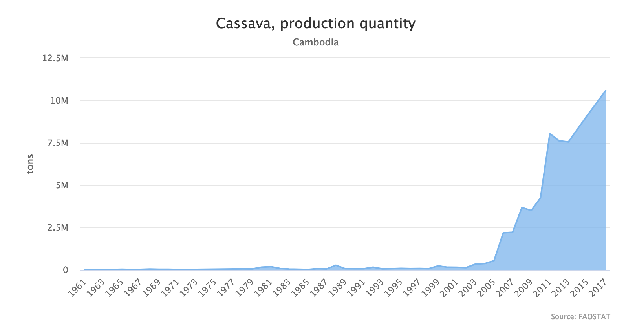
Cassava production in Cambodia has undergone a massive boom over the past decade (Figure 1), the vast majority of which has been enabled by an astounding expansion of the total area cultivated (Figure 2). This trend has come at the expense of marginal lands and forest, with any visitor to Northwest Cambodia struck by the extent of expansion as well as by the utilisation of marginal lands. Explanations for this trend are inconclusive, though many argue that, ultimately, consumption patterns in China tend to drive commodity prices in Cambodia, especially for animal feed products such as bitter cassava. Like the pronounced increases of production and area dedicated to cassava, price volatility is equally striking, though information of farmgate prices received by farmers is unknown (see below for the extreme variability amongst the sampled farmers).
Figure 1: FAO Stat data (http://www.factfish.com)
Figure 2: Cassava Quantity in Cambodia (http://www.factfish.com)

The baseline survey of ASEM/2013/003 is most associated with Objective 1, which aims to: Determine farmer PSPs with reference to agricultural technologies and best practices. Farmer PSPs is a conceptualisation used in to emphasise the assemblage of considerations that shape farmer awareness, intention, and practices. It is also a response to the general focus on ‘barriers’ within the agricultural literature, which tends to focus on farmer practices (Azam, Imai, & Gaiha, 2012; Fleming & Vanclay, 2010; Le Dang, Li, Bruwer, & Nuberg, 2014), and the need to extend consideration beyond barriers to the solutions and capacities of farmers. Objective 1 is oriented around three research questions:
Research Question 1: What problems do farmers perceive, what do farmers think should be done, what do farmers think can be done by whom (i.e., farmer PSPs)?
Research Question 2: Which agricultural technologies do farmers identify as part of their PSPs and why?
Research Question 3: How and why do farmer PSPs differ with regard to sub-groupings (i.e., small, medium, large, poor, marginalised, and female-headed).
These research questions are both directly (i.e., farmers asked directly about their problems-solutions and pathways for change) and indirectly (i.e., triangulated from their responses to multiple questions) explored using the baseline quantitative survey. Research questions 1 & 2 are answered in the conclusion of this report.

Methodology
A quantitative survey of farmers was undertaken with the aim of establishing a baseline understanding of farmer perceptions of experienced problems, possible solutions, and preferred implementation pathways (i.e., PSPs). In order to establish these perceptions, and in order to provide a basis for analysis and later comparison with qualitative data and follow-up surveys, the baseline survey sought basic household information in addition to farming-specific information.
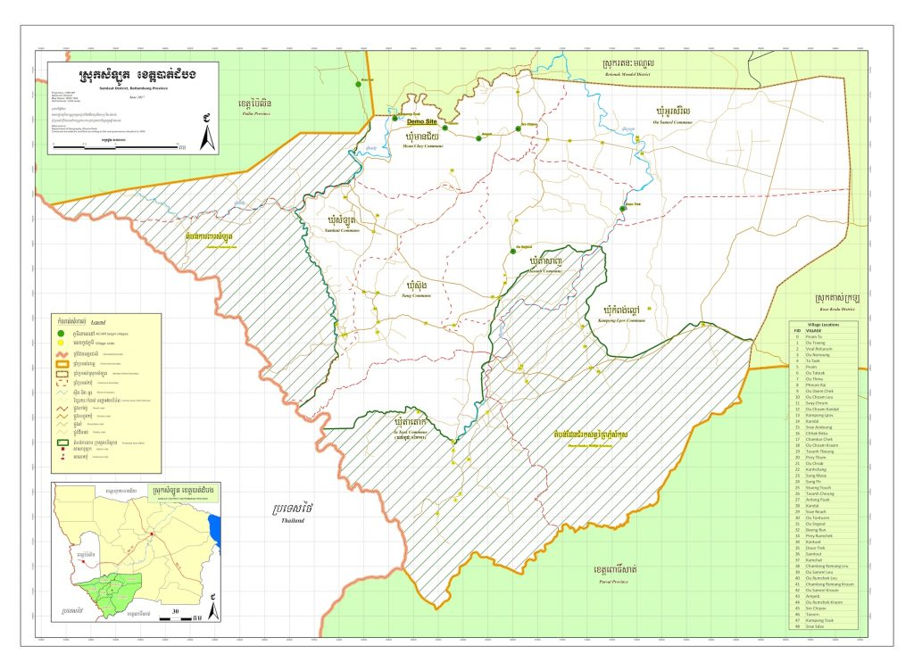
Figure 3:ACIAR Samlout Case Study: Village Locations
The survey was delivered in 13 villages surrounding the two demonstration farms, with a random sample of 406 cassava farmers. The sample was established using the ‘village book’, which is a list of village members held by the village leader. This represents a problematic reliance on village leaders, but interactions with villagers require village leader permission and was therefore a necessary compromise.

Data Analysis
Statistical analysis was undertaken by Dr. Nicholas Read, a statistician hired by the project. He undertook significant time to ‘clean’ the data and to run the statistical analyses, which were made available to the research team.

Findings
The analysis is divided into 10 sections:
- Farm household profile: which presents the characteristics of the sampled households;
- Land: which analyses different sizes, uses, and types of land holdings amongst the sampled farmers;
- Labour: which analyses reported labour types including on/off farm activities;
- Income: which attempts to tabulate income from various reported sources;
- Cassava: which attempts to analyse the profitability of cassava production amongst the sampled households;
- Loans: which analyses the number and amounts of debt held by cassava households;
- Fruit tree crops: which explores efforts to transition to fruit tree production;
- Pests and disease: which analysed the presence and impact of reported pests and disease on cassava production and profitability;
- Gender: which analysed across the various data looking for gender-based differences;
- Future outlook: which included more open-ended explorations of farmer happiness and optimism (or not) in terms of life prospects, using the PSP conceptualisation.

Farm household profile:
The cassava farmers who participated in the research are predominantly male-headed (74%), married (91%), and with between 4-6 family members living in the household.

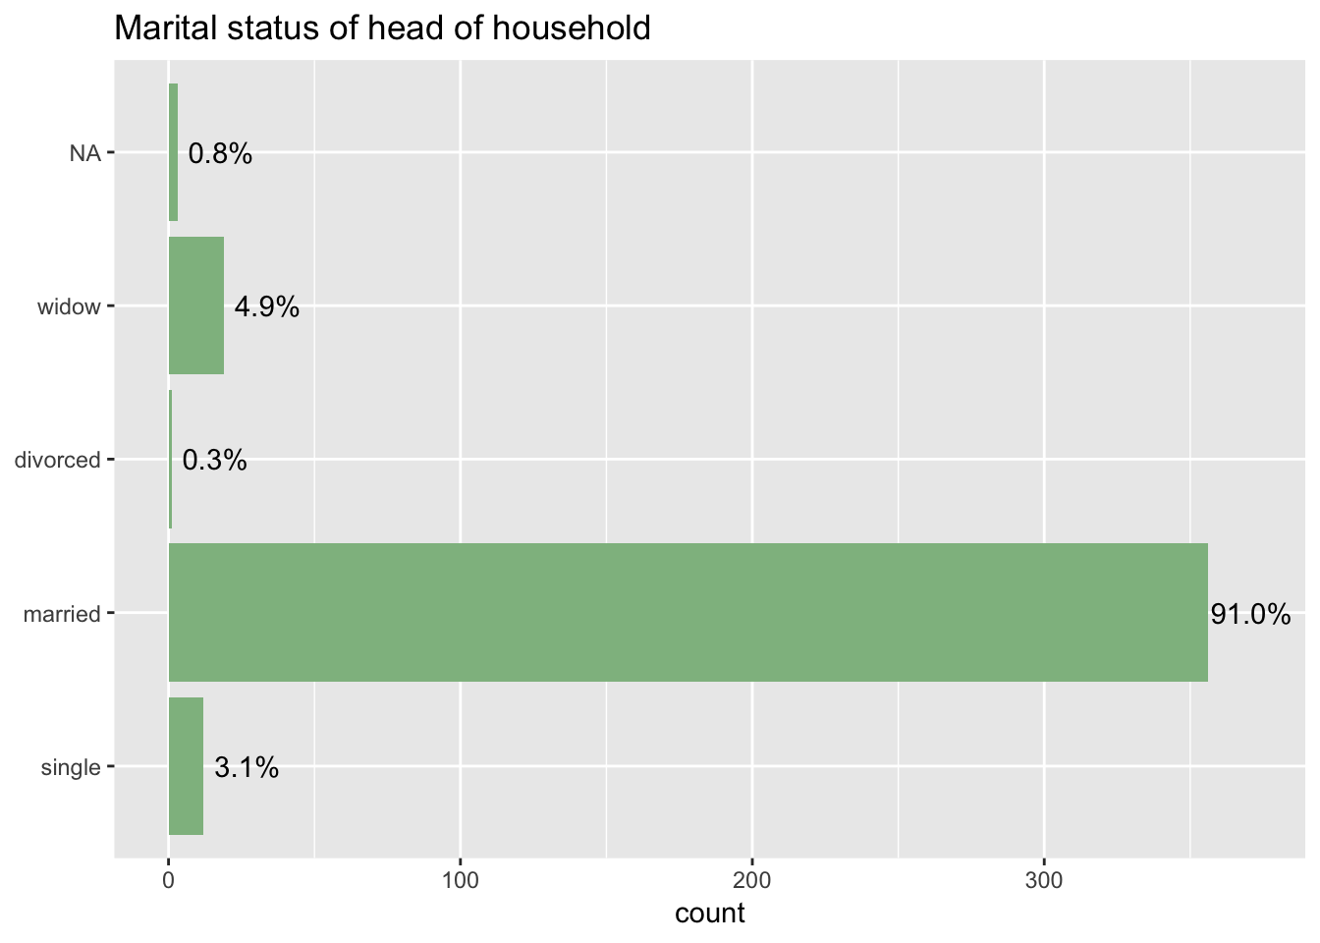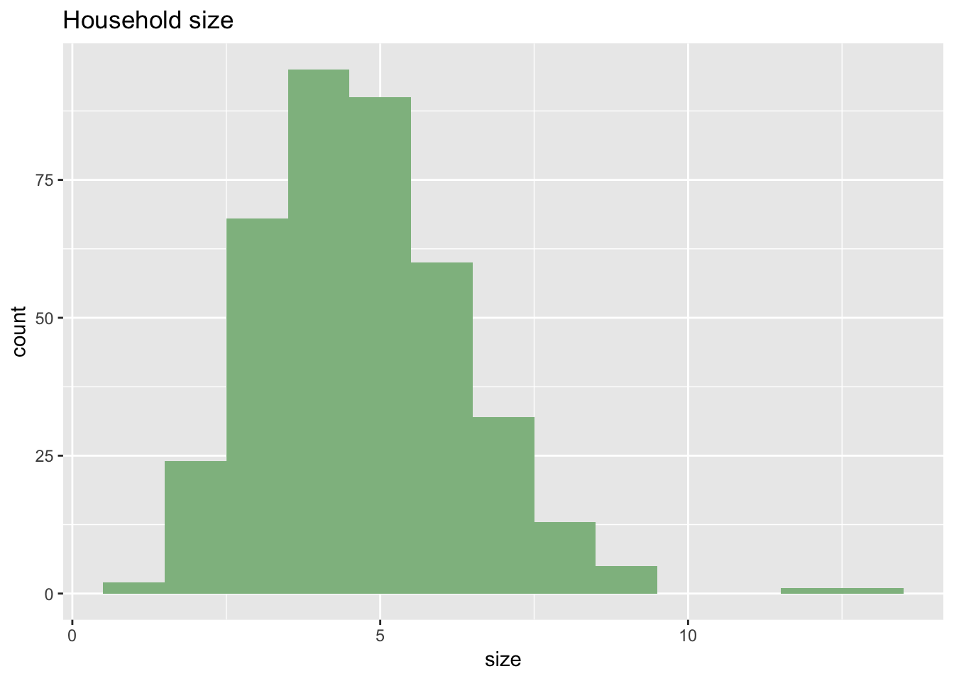

Because of the large size of the family units (along with the survey already being very long) the survey design required that we focus attention on the head of household (HoH), rather than collect individual data for each family member. A substantial number of households (25%) self-reported a female HoH, which provides an ability for later comparison and analyses of differences amongst household ‘types’. Overall the HoHs tended to have primary-level education (51%), with a significant number of HoHs attending upper levels of education (17% secondary, 10% high school).

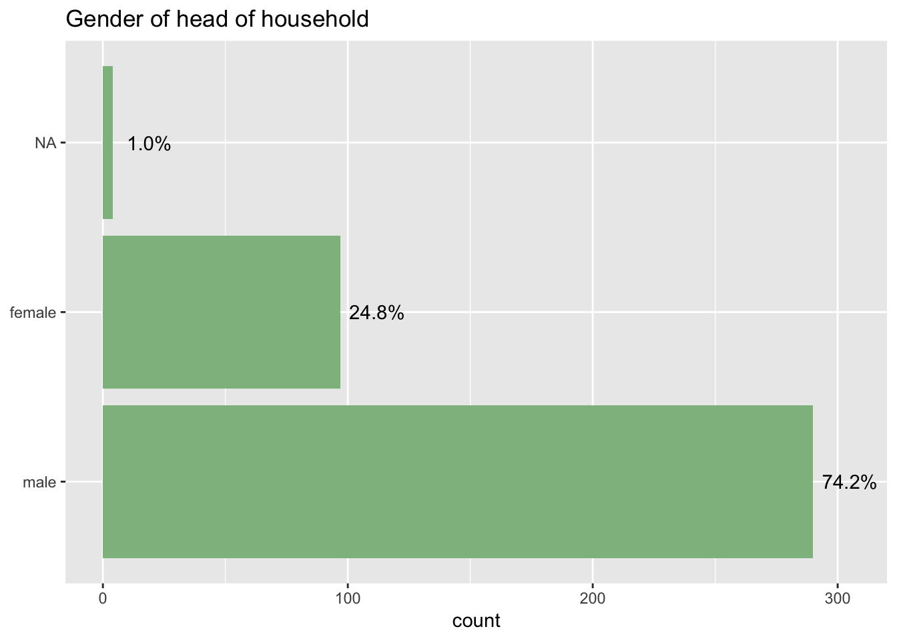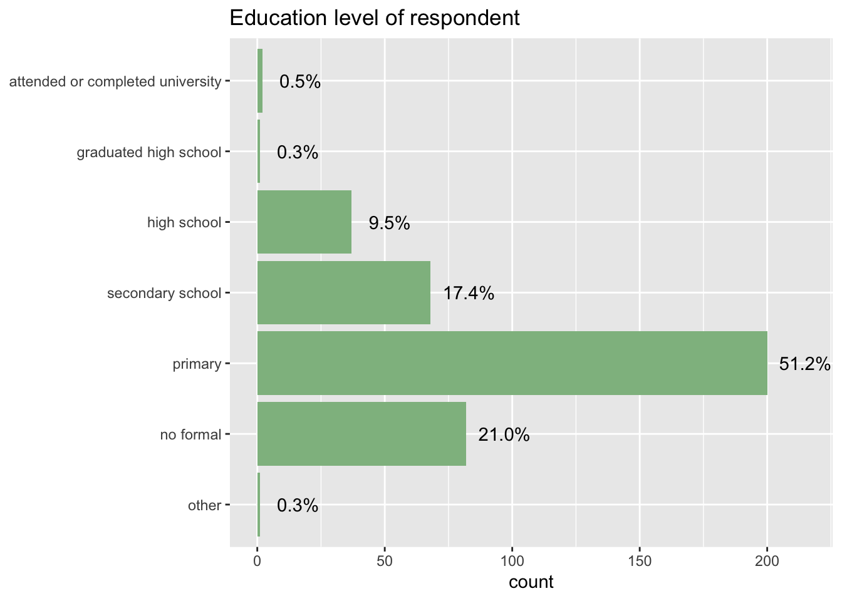
Figure 4 Figure 5:

Land
Land holdings are, arguably, the most important asset for farmers with regards to understanding poverty, marginalisation, capacity, and opportunities for practice change. As such, the survey dedicated substantial energy towards understanding farmer household land-holdings. This is an extremely challenging, as well as highly sensitive, issue in Cambodia. Land redistribution was a focal point of the Khmer Rouge regime, with lingering impacts on land holdings to the present day. It is only relatively recently that the consolidation of land by elites has come out ‘from the shadows’, having historically been hidden. As explained by Li (2014) in the context of Indonesia, the vague and uncertain nature of land title in Cambodia is likely to have favoured those with power and the ability to informally acquire and maintain land. As opposed to strict regulation and clear rules, elites appear to have successfully utilised the tenuous nature of land titles in Cambodia to increase their holdings; anecdotally, farmlands are thought to be ‘good investments’ for city investors, whose access to funds substantially outweighs local farmers. Land remains a very sensitive topic during discussions with farmers, but it is also an essential element of any analysis or discussion of rural development and agricultural change.

Like the number of household members, farmers in the Northwest of Cambodia tend to farm numerous plots of land. Again because of the time needed to complete the baseline survey, we focused on the primary plot of land. Farmers were therefore surveyed about the ownership status of their primary parcel of land, but with area included for their total land holdings (Figure 6). We used this information to further differentiate between land owned with title, land owned without title, and land owned but used as a secondary parcel of land. Of the surveyed farms, 53.9% owned one or fewer parcels of land whilst 87.3% of farms owned two or fewer parcels. We have no information about the ownership status of the non-primary parcel of land.

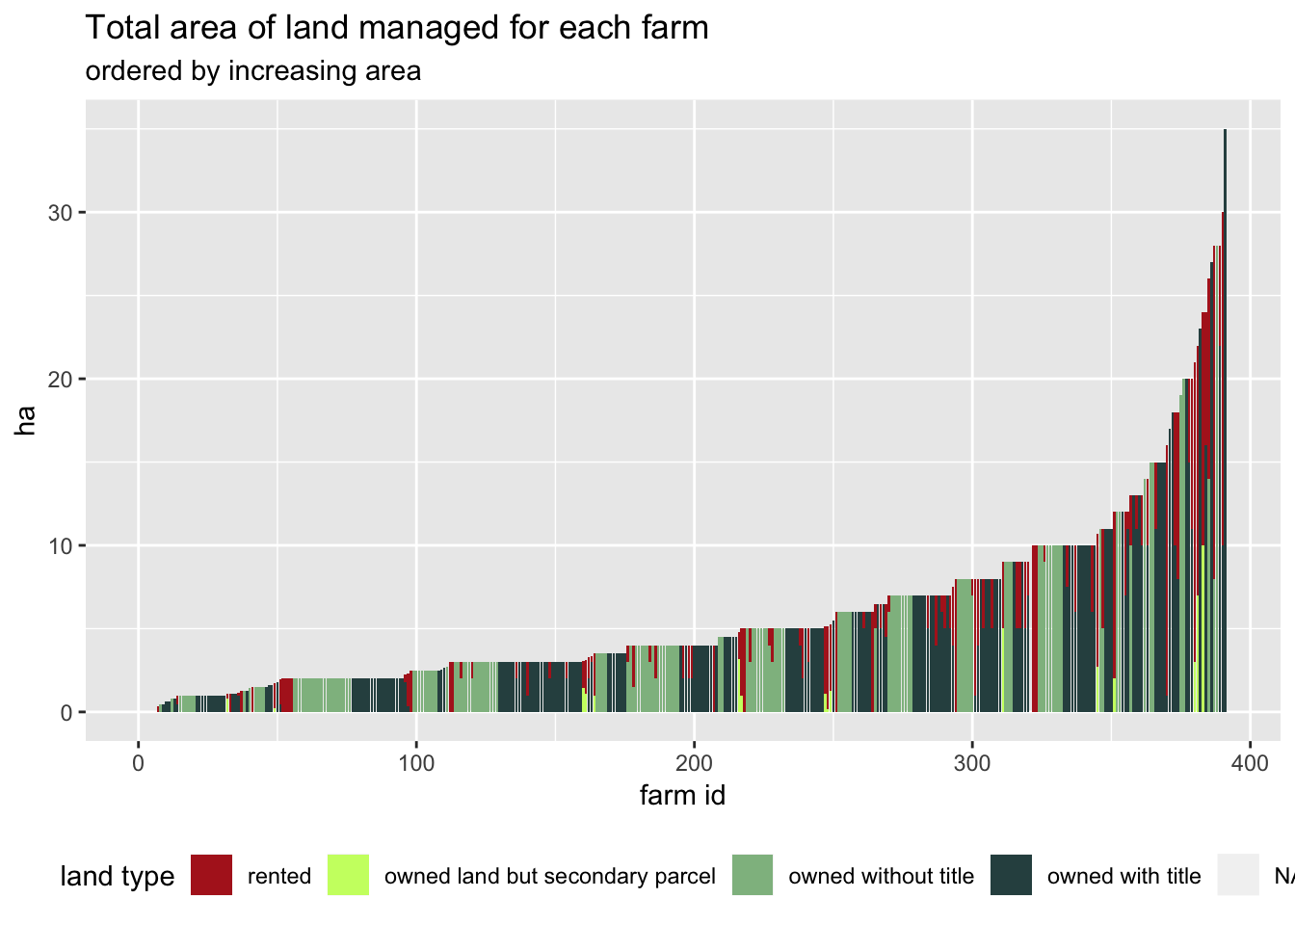
Figure 6: Total land area with colour-coding to distinguish owned, rented, primary, and with/out title (i.e., deed)
Because of the importance of ownership legitimacy (established via State-based documentation) the data is analysed to differentiate farmers whose holdings are more or less secure. The data show variety of land holdings amongst the majority of farmers (i.e., approximately half of sampled farmers have multiple holding, some with different types of land title) (Figure 6). There is also a significant number of ‘rental-only’ farmers (left side of Figure 7), though with a relatively surprising few who only rent but are farming on very large plots of land (i.e., greater than 15 ha). Additionally, the area managed (i.e., owned + rented) indicates a significant number of farmers with secure land title also renting large plots of land to amplify their farming activities. This is potential confirmation of relatively well-off farmers taking advantage of scale in terms of mechanisation, harvest, and possible the ability to negotiate better prices.
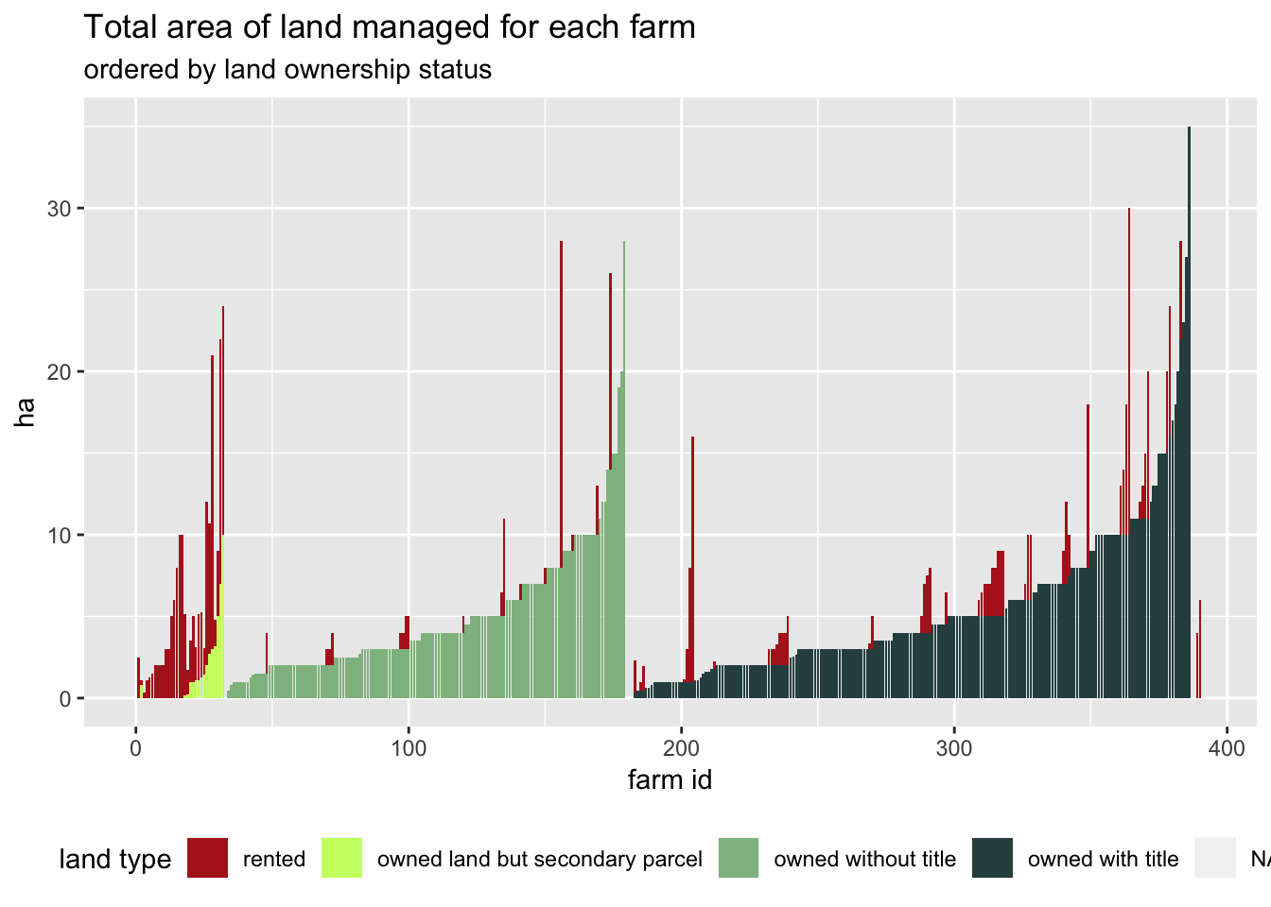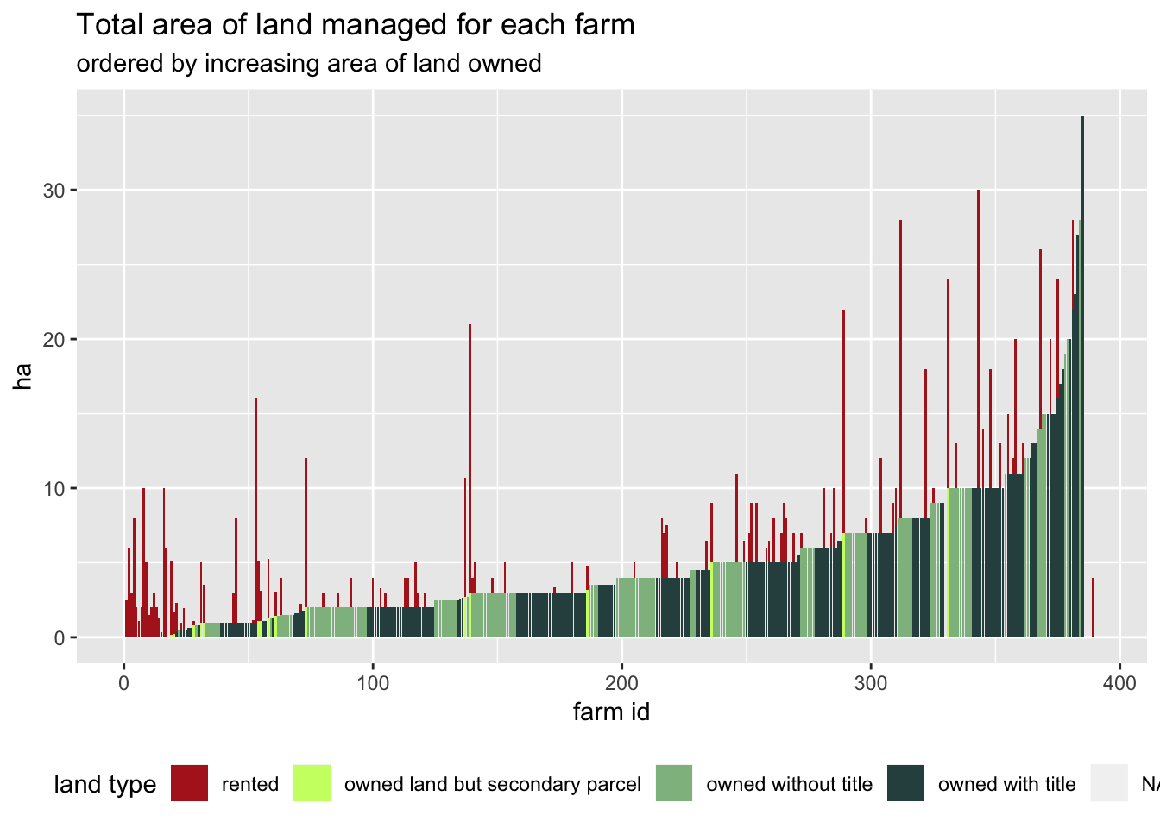
Figure 7: total land by ownership Figure 8: total land by area

Labour
Not surprisingly because of the sampling procedure of choosing cassava farmers, the vast majority of HoHs dedicate their full time to agriculture. Despite this likelihood, confirmation that 93% of HoHs work full-time in agriculture is a helpful finding for understanding household dynamics. This is particularly pertinent to the discovery that cassava farming households appear to allocate two individuals to farming, with other members of the household working off-farm.

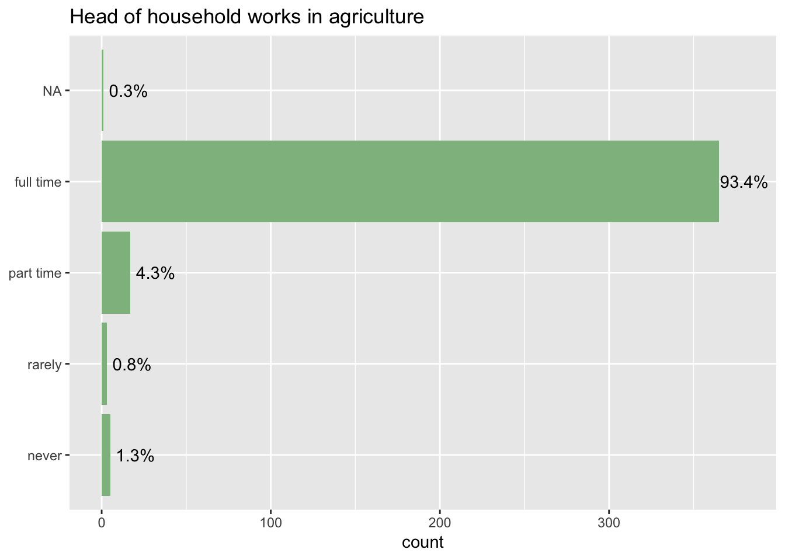
Figure 9: Percentage of annual labour of HoH in agriculture
Figure 10 shows the counts split by number of family members working inside/outside of agriculture. We see a diverse makeup of farms. For example, farms with 4 members correspond to the positions (1, 4), (2, 3), (3, 1) and (4, 0) which have counts 12, 52, 17 and 18 respectively, showing a relative spread in behaviours of 4 member farms. Interestingly, for all family sizes the most popular number of members to work in agriculture is 2.

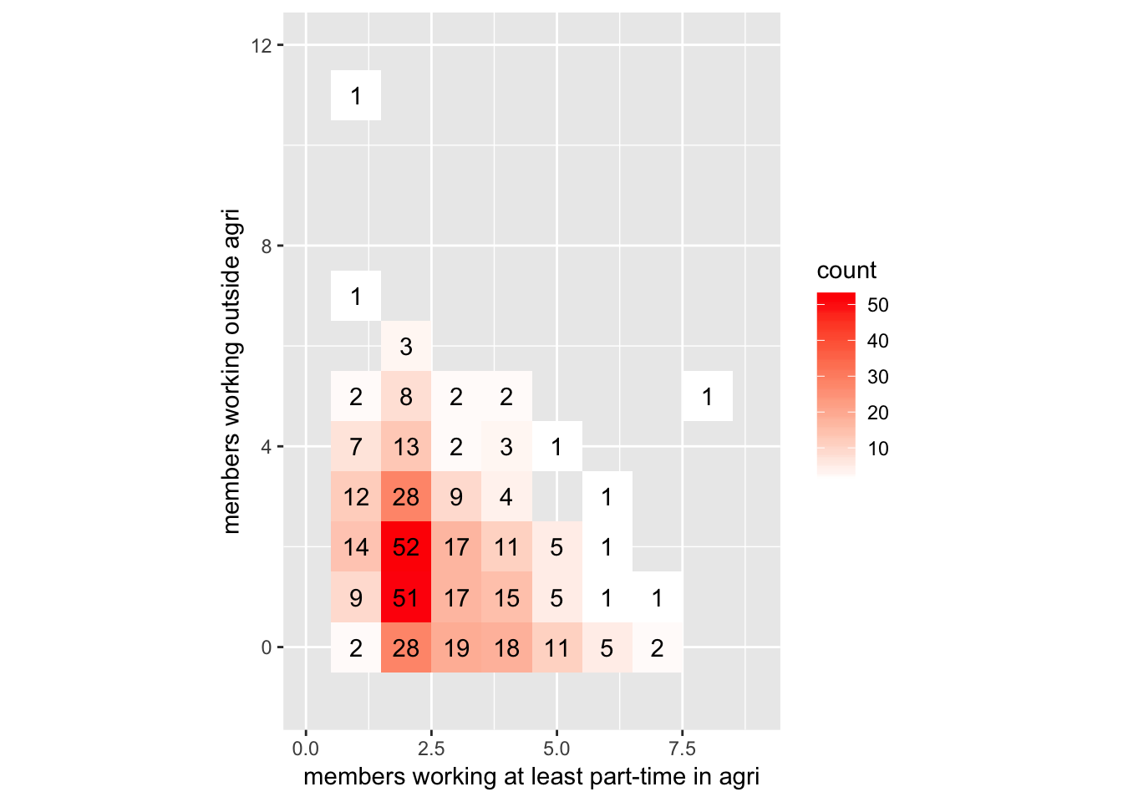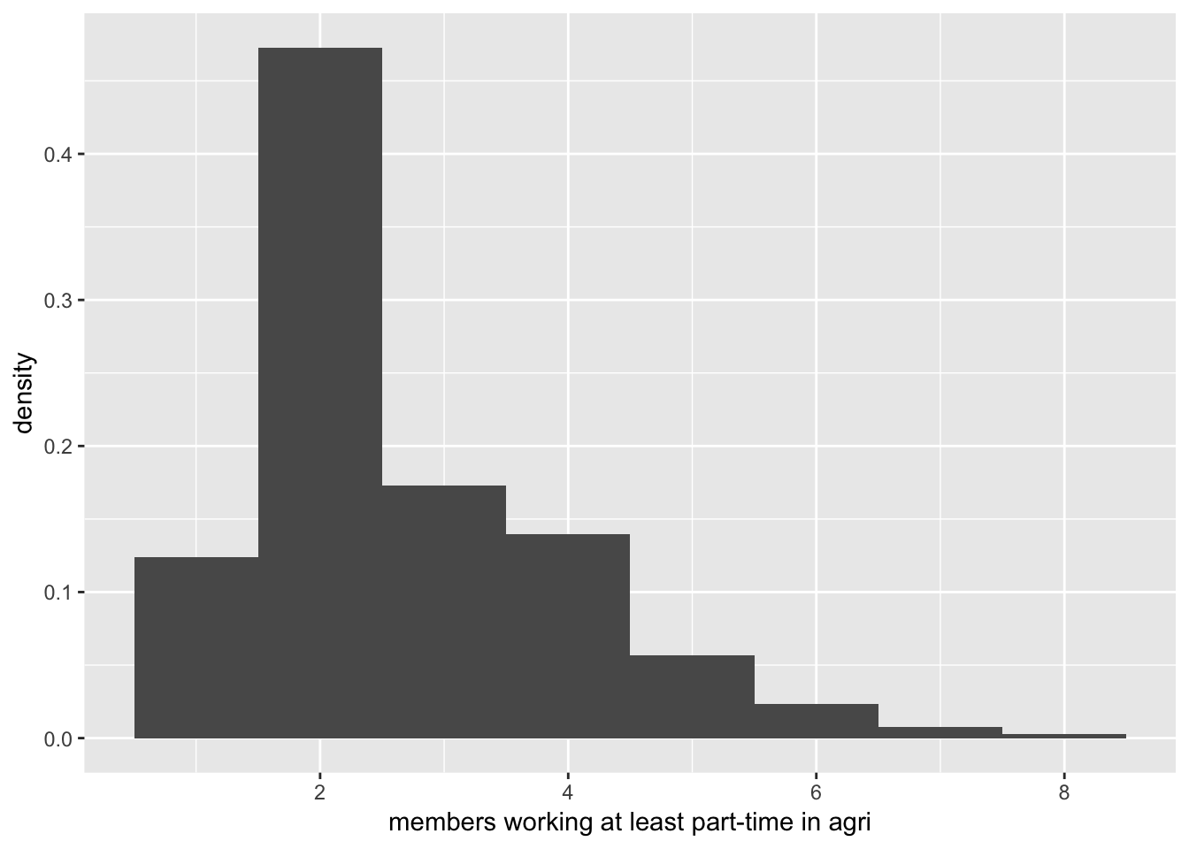
Figure 10: number of family in Agriculture Figure 11: histogram of family members in Agriculture
We can also look at a histogram of the number of household members working (Figure 11) at least part time in agriculture and the number of household members working entirely outside agriculture. These correspond with the “marginal” values from figure 10. We again see that 2 household members working in agriculture was the most frequent response. The finding that households allocate two individuals to agriculture may be a significant finding with regards to how labour is allocated, especially when considering the rise of off-farm labour, changing family compositions, and opportunity costs.

Income
Income is (by far) the most problematic theme explored within the household survey. There are numerous confounding issues associated with income, including people’s general tendencies to not want to discuss income with strangers, as well as tendencies to exaggerate (both positively and negatively) the information in order to portray desired personas. Further complicating calculation of income amongst cassava farmers is that they often do not keep records of their expenditures or incomes. Furthermore, they are also often operating on credit with lenders who are simultaneously providing inputs for their on-farm activities , often with unclear costs and interest rates. The diversity of on-farm practices (i.e., cassava, fruit tree, livestock) and that these practices operate on entirely different timing cycles, means that farmers often have a limited ability to communicate exact figures. Finally, there are no reliable proxies within the literature to estimate wealth amongst these farmers, reflective of the paucity of reliable research that explores their livelihoods.

On-farm income is calculated using farmer reported incomes drawn from livestock, tree crops, upland crops, and cassava. These specific data must be cautiously examined, with findings or conclusions only suggestive. As such, it is interesting to see the ‘long tail’ of income (Figure 12), which supports the widely held and unsurprising belief that farmers are poor (i.e., the vast majority reporting total income under $5,000/year). Also unsurprising given the sampling, Cassava is clearly the most important crop for the vast majority of farms.
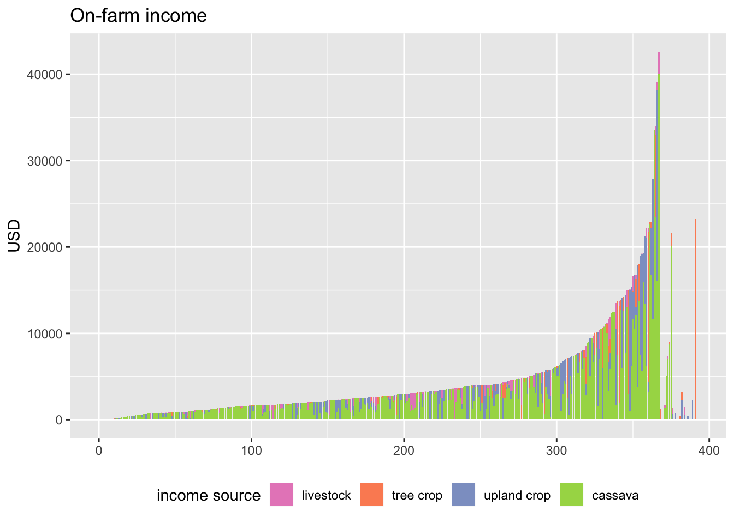
Figure 12: far right findings because N/A chosen for some incomes.
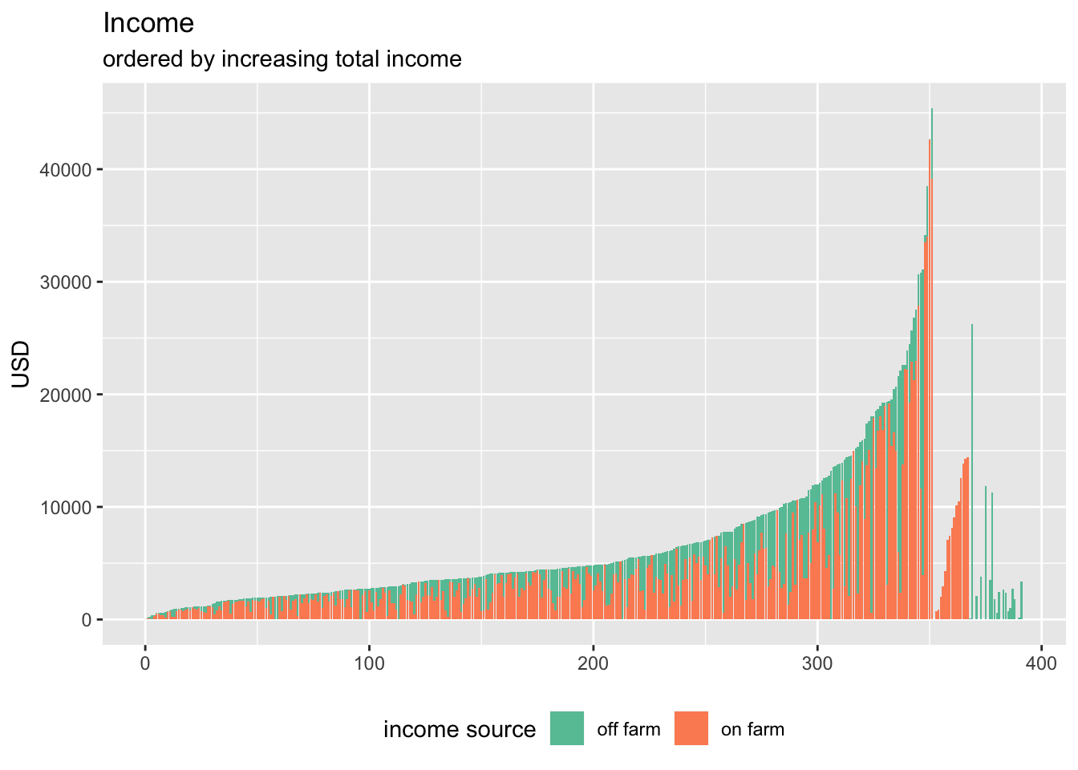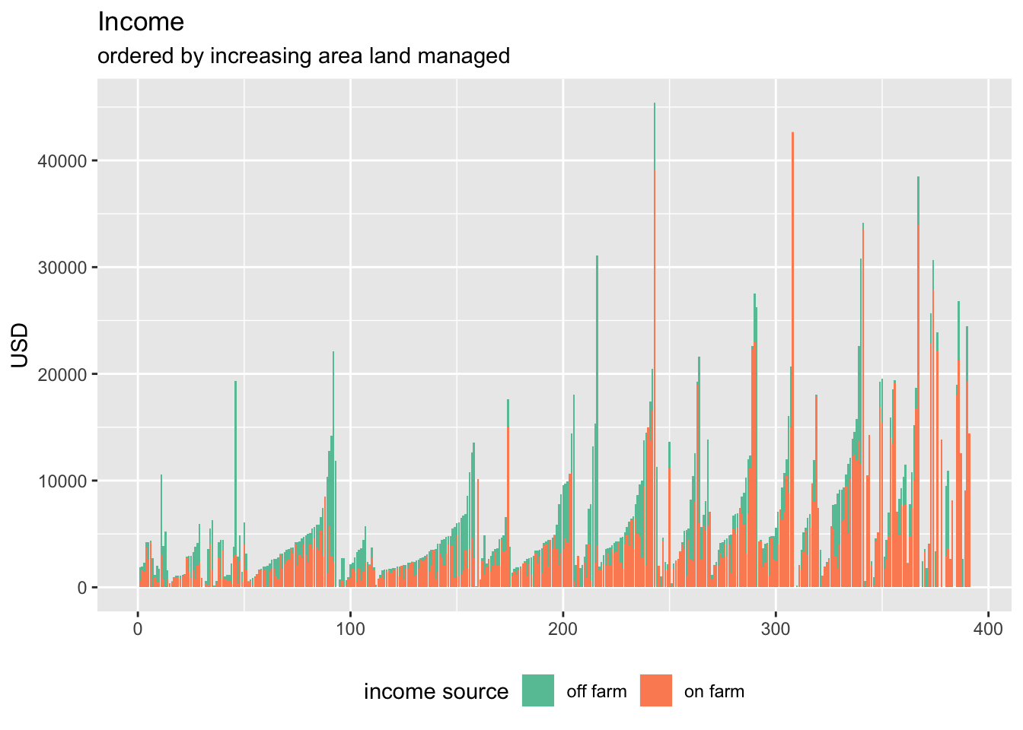
Figure 13 : ordered income inclusive on/off farm Figure 14: differentiated by land area
The labour allocation within households (see above) also means that most of the households receive off-farm income for at least parts of each year. Figure 14 suggests that off-farm income becomes a smaller proportion of total income with land size, confirming the challenges facing smallholders and the adaptive strategy/necessity of diversified incomes. Further complicating matters, there may be individuals sending remittances that are not listed as a member of the household and therefore overlooked in these calculation. Of the farms that responded that no household members worked off-farm (14.6% of farms), 70% had income from remittances or “other” sources, possibly indicating support from extended family but likely a member of the immediate family who has sought work in Thailand or another urban centre. For some of these farms, large proportions (as much as 91%) of their total income came from these sources. When comparing on-farm income against area of land managed, perhaps the most important (and only) reliable findings is recognition for the extreme variability and caution that must be taken when considering the data (Figure 15).

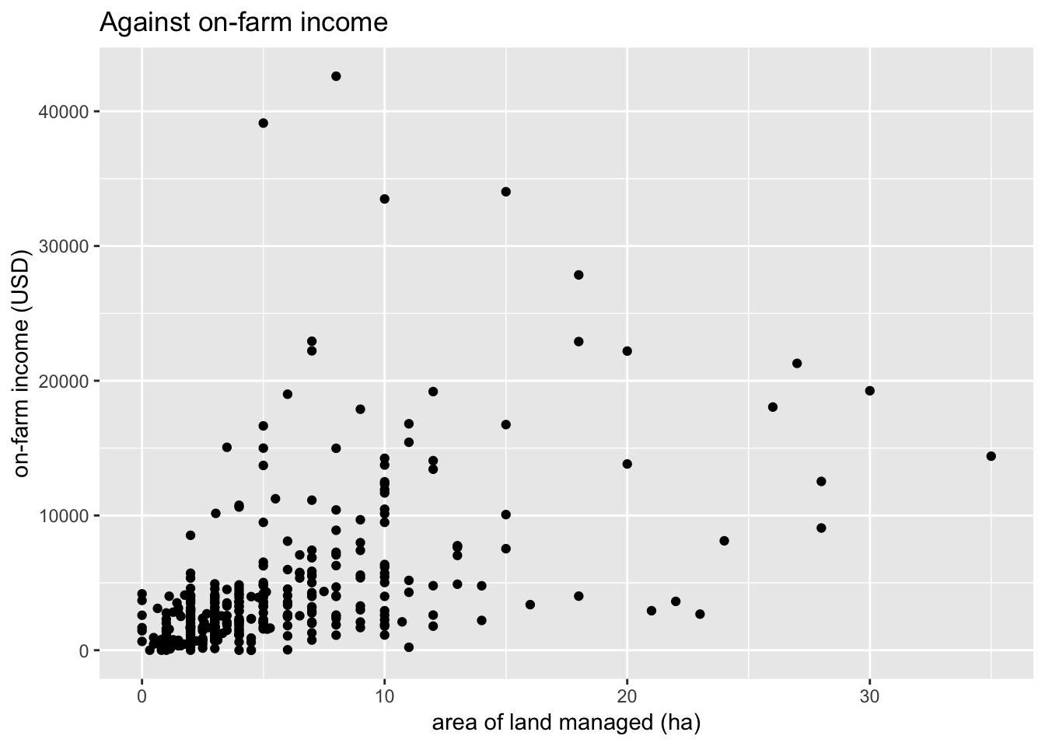
Figure 15: extreme variability of income by land managed
It is important to note the incredible variation in reported price received for upland crops (Figure 17). Note that some conservative preliminary data cleaning has already removed the most extreme points.

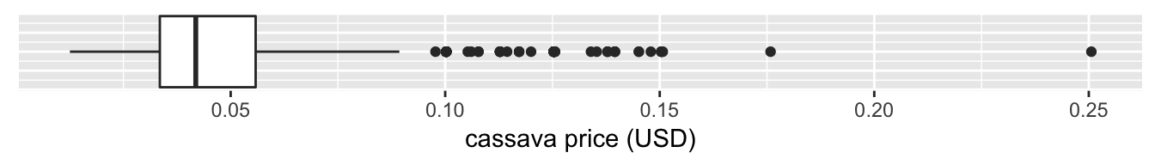
Figure 16:
Figure 16 indicates that there is some incredible variation in the reported prices that the households receive for cassava. The highest price of cassava (even after initial data cleaning) was reported to be 20 times that of the lowest price. Rather than accept the absolute figures, it is more appropriate to recognise that farmers appear to have an extremely variable ability to secure the price paid for cassava, as well as difficulties communicating the prices received. Given the above findings with regards to income variability, this finding (while problematic) does contribute to a conclusion that farmers are likely to be receiving vastly different prices for their product. Further analysis is needed, especially with regards to the time of year that they are selling, to who, and under what circumstances. Indeed, high variation in reported price is common to all the upland crops. We have removed sugarcane, peanuts and pepper since there were only one non-zero observation of each.

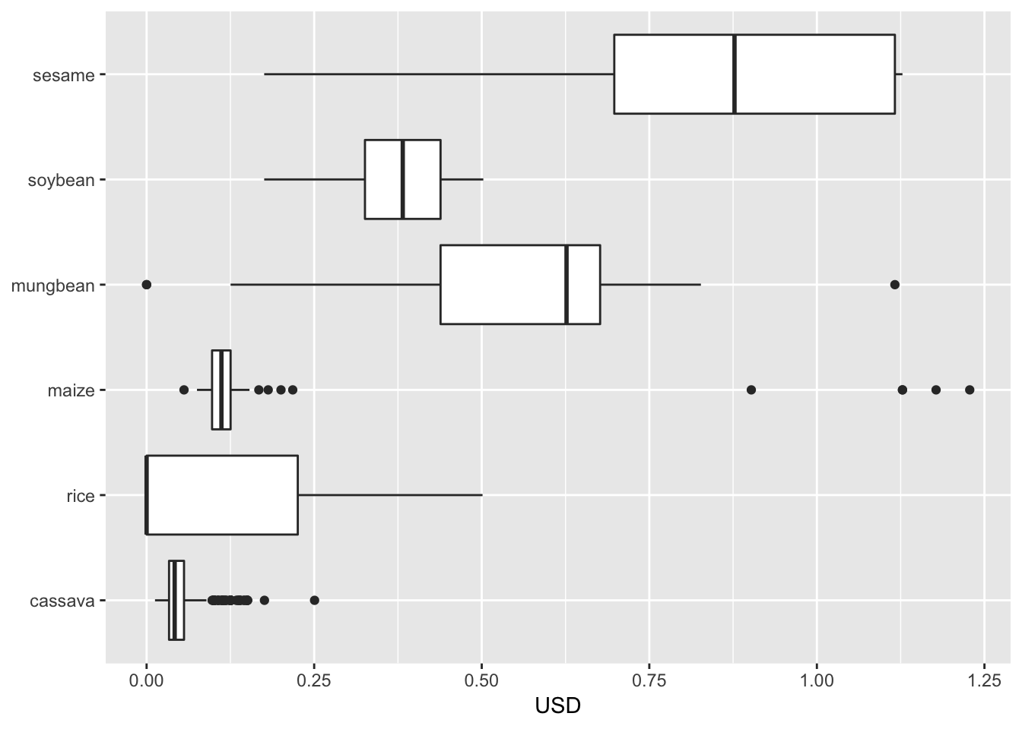
Figure 17

Cassava
We are interested in the production and profitability of cassava as a function of the area of land used. We have this data for 2016, presented in the three figures below. These data show general trends but also significant ‘scatter’; the most reliable reported data being the income relative to Kilograms (Figure 18), which is perhaps indicative of the information that farmers are most familiar with (i.e., weight is how they are paid when they deliver their product to the silos). Similarly, the scatter of the figures associated with area confirm the belief that farmers have a relatively poor understanding of the total area that they farm.
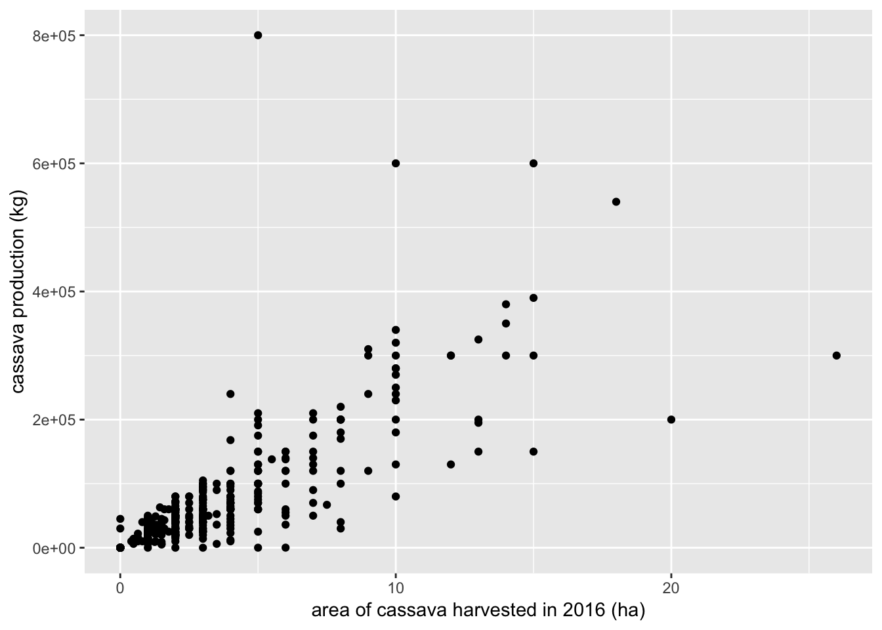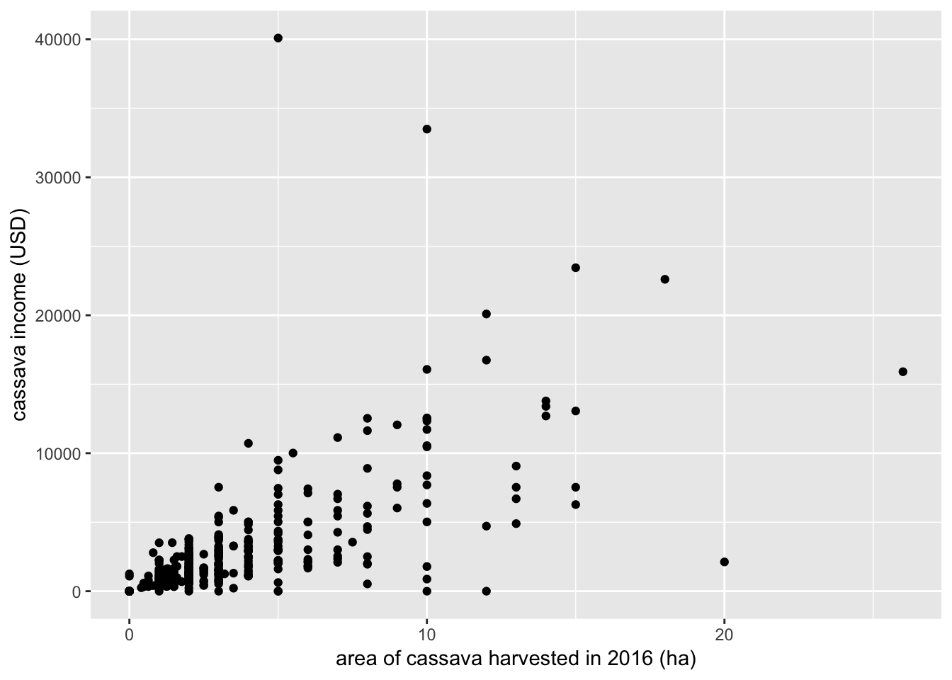

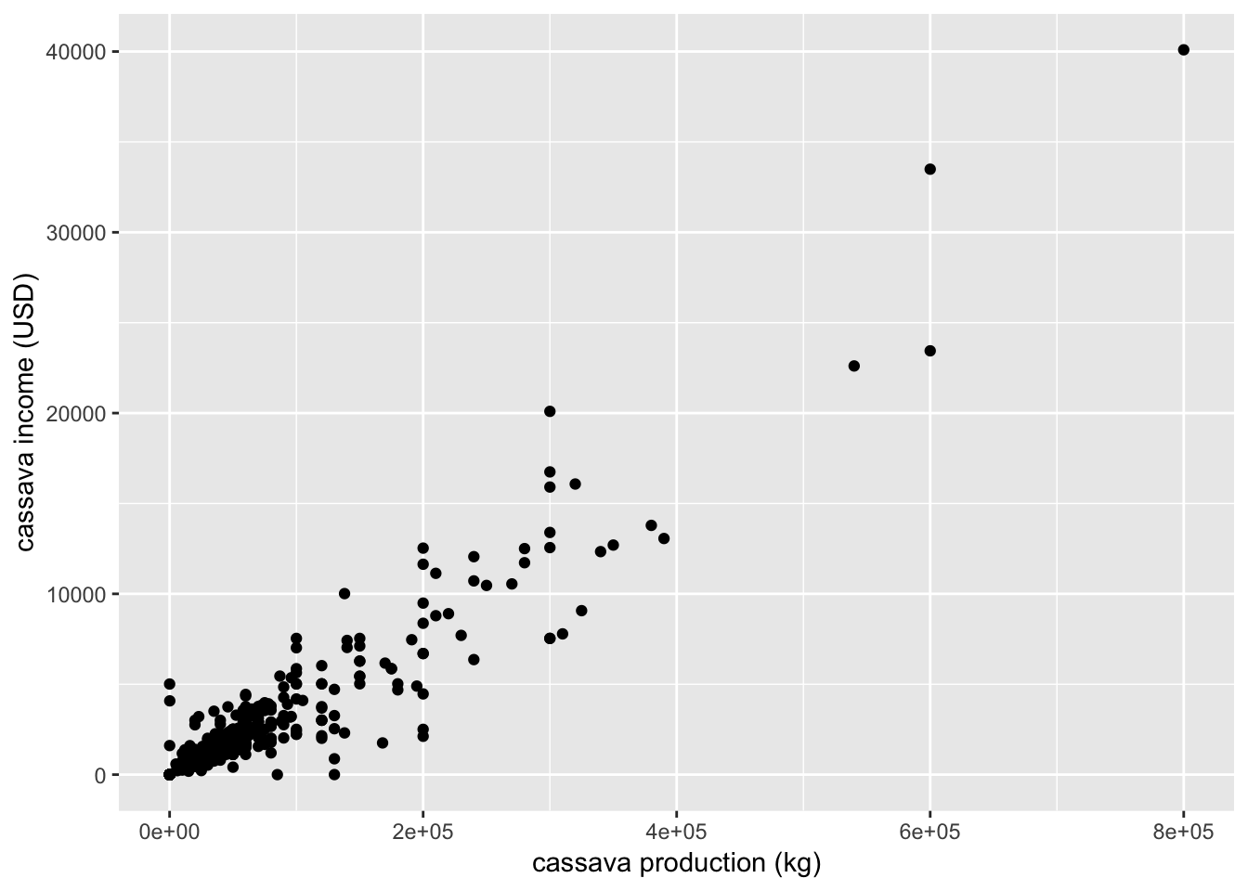
Figure 18: income by kilograms

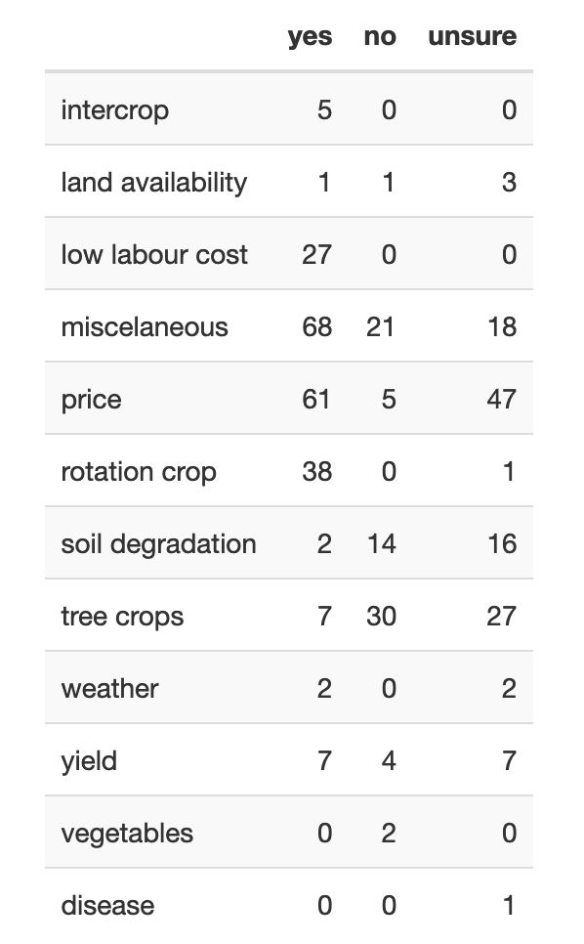
Key to understanding farmer decision making is appreciation for farmers’ future outlook. Farmers were asked if they thought they would be planting cassava in five years’ time. The responses were: Yes (n=209), No (n=69), and Unsure (n=113). Farms were asked why or why not they believed they would be planting cassava in five years’ time. These worded responses are extremely brief, such as “price of cassava gets better this year”. Some of the responses are difficult to interpret, such as “she’s getting very old”, whilst others are more straightforward. We have made a rough attempt to streamline the responses to this question into broad categories such as ‘price’, ‘yield’, ‘soil degradation’, and ‘tree crop’. Responses that were not easily categorised were put into the ‘miscellaneous’ category. For some ambiguous responses a subjective decision was made to categorise the response. For example, “easy to earn money” was categorised as ‘low labour cost’ although it maybe it should be put in the ‘price’ category. Note that responses such as ‘land no fertilizer’ were classified as ‘soil degradation’ and responses such as ‘have market demand’ were classified as ‘price’. Many responses reflect the need for good a cassava price, but some mention the volatility of the price being a problem. Both were categorised under ‘price’. Further note that farms could give multiple reasons, although no farms gave more than two. The table shows the number of times the response was given, hence a single farm can make a contribution to up to two cells.
Figure 19:Considerations affecting cassava production

Loans
Many researchers have argued convincingly that debt and indebtedness are central to the lives and livelihoods of farmers (Bateman, 2018; Cramb, Manivong, Newby, Sothorn, & Sibat, 2016; Mahanty & Milne, 2016), with cassava farming households in the Northwest of Cambodia likely to fall into such experiences. Furthermore, recent research has shown that the struggle for land is often an extremely gendered conflict (Lamb, Schoenberger, Middleton, & Un, 2017), in which State-Publics struggle for recognition and access to what have often been common or marginal lands. Like income, loans and indebtedness are sensitive topics, with necessary caution needed when considering the data.

Amongst the surveyed farmers, roughly 99% had at some point made use of credit and loans, with approximately half holding two loans simultaneously. Cambodia is well known internationally for the availability of credit supplied to farmers (Bateman, 2018), with many arguing that lending practices are dangerously lax. Farmers were asked about the manageability of their debt (Figure 20) with the majority of farmers with loans indicating that they held manageable or very manageable levels of debt – a surprising finding.

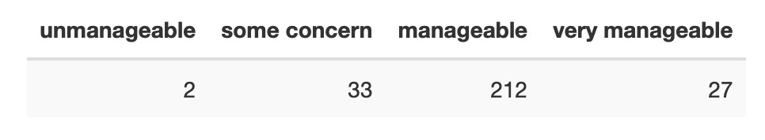
Figure 20: responses from farmers on the manageability of their debt
We can visualise these debts against land size and income, highlighting farms that responded they felt ‘some concern’ or ‘unmanageable’ about their levels of debt. Note that we only have information on the value of the most recent loan. Some 78 farms reported more than one loan, suggesting there could be significant debt excluded from our data set. The data does suggest that those with the larger number of loans were more likely to indicate concern with their ability to repay the loan; additionally, concern for the ability to repay tended towards farmers with smaller land holdings, which might be expected given their limited abilities to increase production or limit expenses.

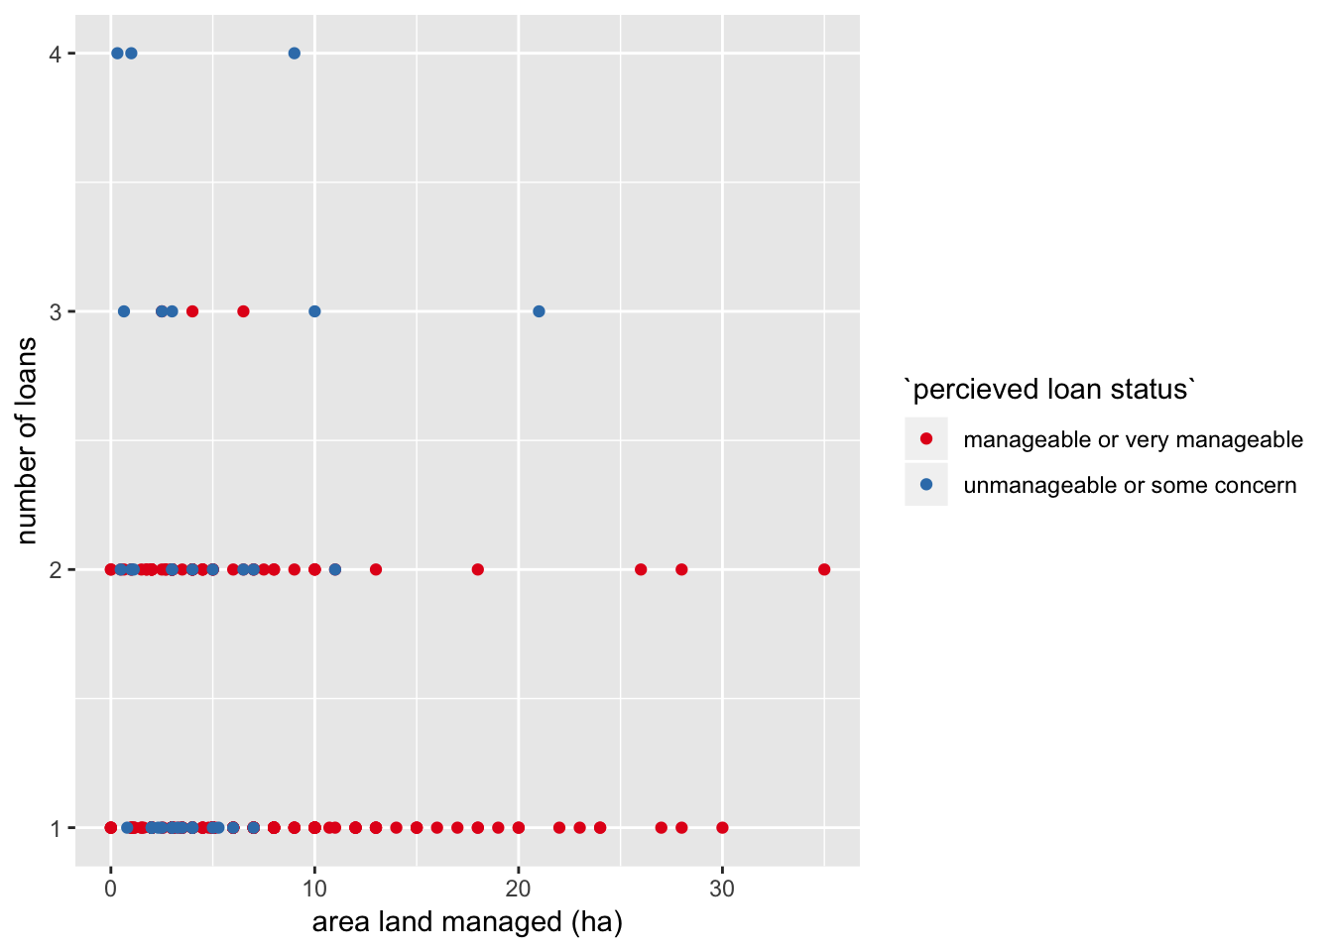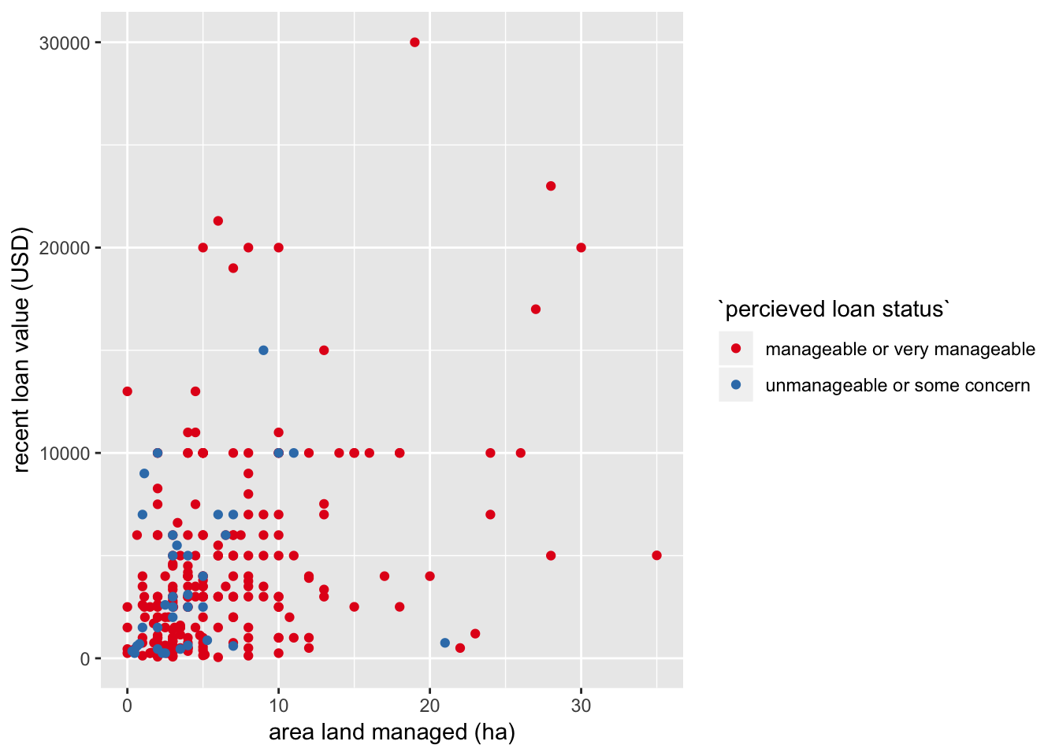
Figure 21: loans by area– and manageability Figure 22: value of loans by area – and manageability
Farmers were asked about the stated purpose of their loan compared to its actual use; it is, perhaps, surprising that households were willing to disclose that they often used loans for alternative practices, which is a testament to the research team from PRD. Of farms with loans, 88.7% used their loan for its stated purpose. Of farms with loans, 162 noted a single use, 101 gave two uses, and 11 gave three uses of the loan.
Figure 23: Stated use of loan

Figure 23 shows the total number of responses to each of the categories. Note that a single loan can have multiple stated purposes and uses, hence could contribute to multiple rows.

Fruit tree crops
Farmers were surveyed about income, area, and the number of tree crops grown on their land. No farm responded with the area of tree crops grown, leaving us with data on the income and number. Farmers were asked about eight different tree crops: mango, rubber, durian, longan, mangosteen, rambutan, cashew and pomelo.

Figure 24: fruit trees crops grown in Northwest Cambodia
During the first half of the research project – and confirming the farmer desires uncovered both through farmer PSPs (below) and preliminary household interviews – we are in the midst of a significant transitional period for farmers with regards to fruit trees. Figure 25 is an extremely difficult image to make sense of, though it does appear to suggest two trends (or perhaps temporal periods) for farmers transitioning to fruit tree production: 1) in which the fruit trees are beginning to produce profits (blue arrow); and 2) farmers still waiting for the fruit trees to mature and begin producing (red arrow). This interpretation is highly speculative, but aligns with observations on the ground. This plot shows that of the 220 farms which reported having tree crops, 144 had no income from tree crops with a plausible explanation being that these tree crops are still in their infancy. Figure 26 is a plot of the 76 farms reporting an income from tree crops, showing their income broken down by type. Mango and longan are responsible for most of the generated income. Figure 27 displays a very strong presence of mango, followed by longan and cashew. Interestingly, the two largest tree crop farms (in terms of number of trees) have large cashew groves, which may indicate that wealthier farmers are continuing to expand and diversity fruit tree production.

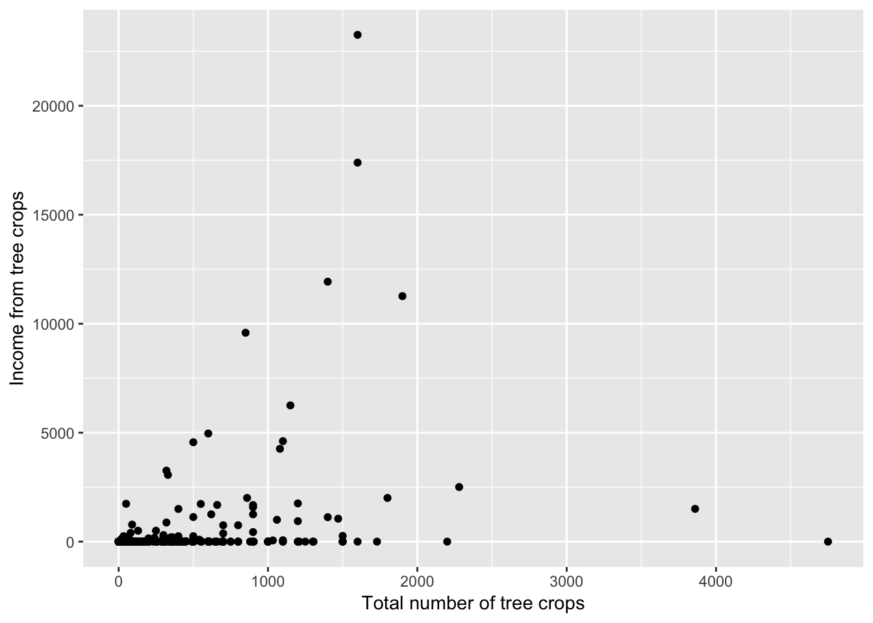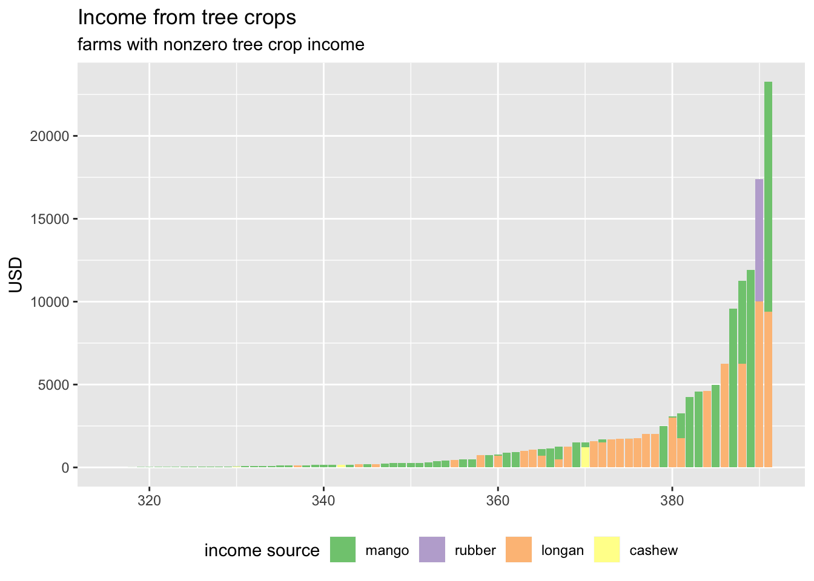
Figure 25: Two trends? Of Trees production and income Figure 26: non-zero fruit tree profits

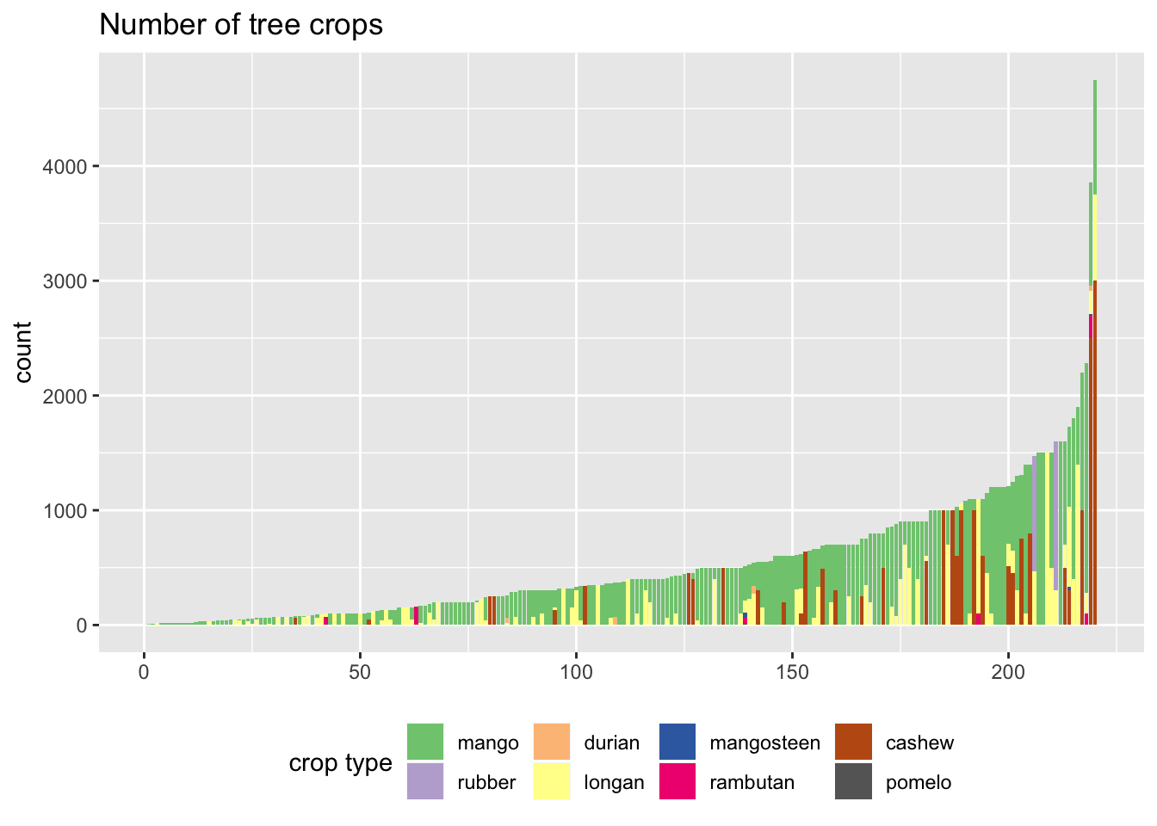
Figure 27: Popularity of tree types
We were interested to see how farmers with tree crops may differ from other farmers. Although there were 220 farms that reported having at least some tree crops, we chose to look at the 201 farms that reported 50 or more tree crops. We did this because we wanted to focus on commercial tree crop farming and we were concerned that farms with smaller numbers of tree crop may be using them for personal consumption. Figure 28 shows the total income of the 201 tree crop farms, ranked by increasing total income. Note that the farms to the right of the drop-off had a missing value in at least one of the income variables and so we were unable to calculate their total income.

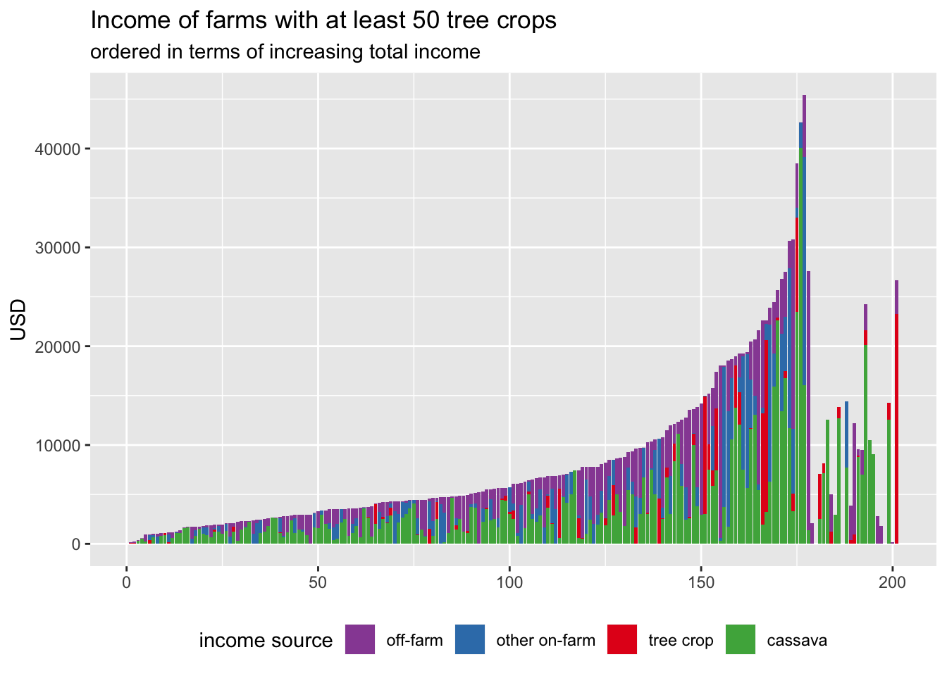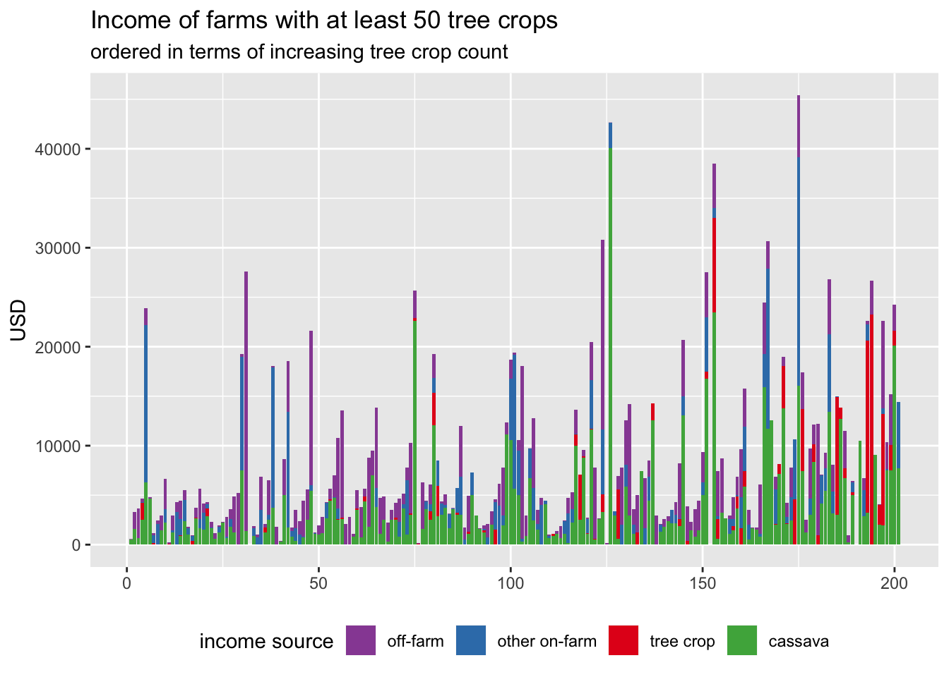
Figure 28 Figure 29
We were interested to see if land ownership status was different for farmers with at least 50 tree crops. Figure 30 shows two histograms, one for farms with less than 50 tree crops and one for farms with at least 50 tree crops, plotted over one another. It shows that tree crop farms tend to own more land, but perhaps not significantly more. Beside Figure 30, displaying the same data using a normalised curve (i.e., both curves have an area of 1), shows that farms with at least 50 tree crops typically owned more land.

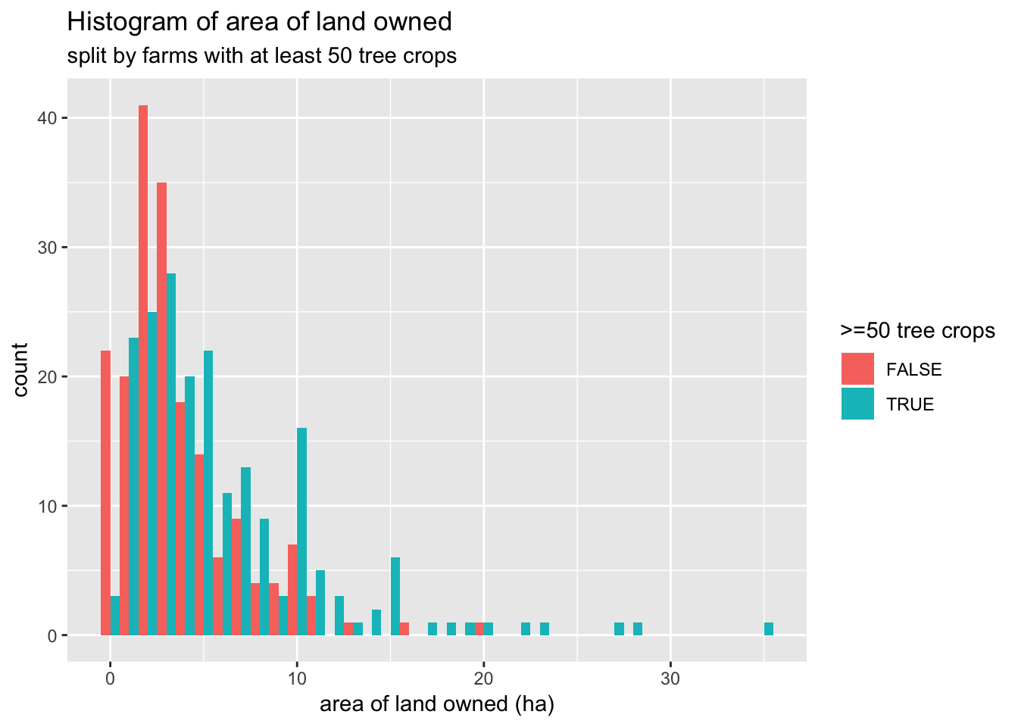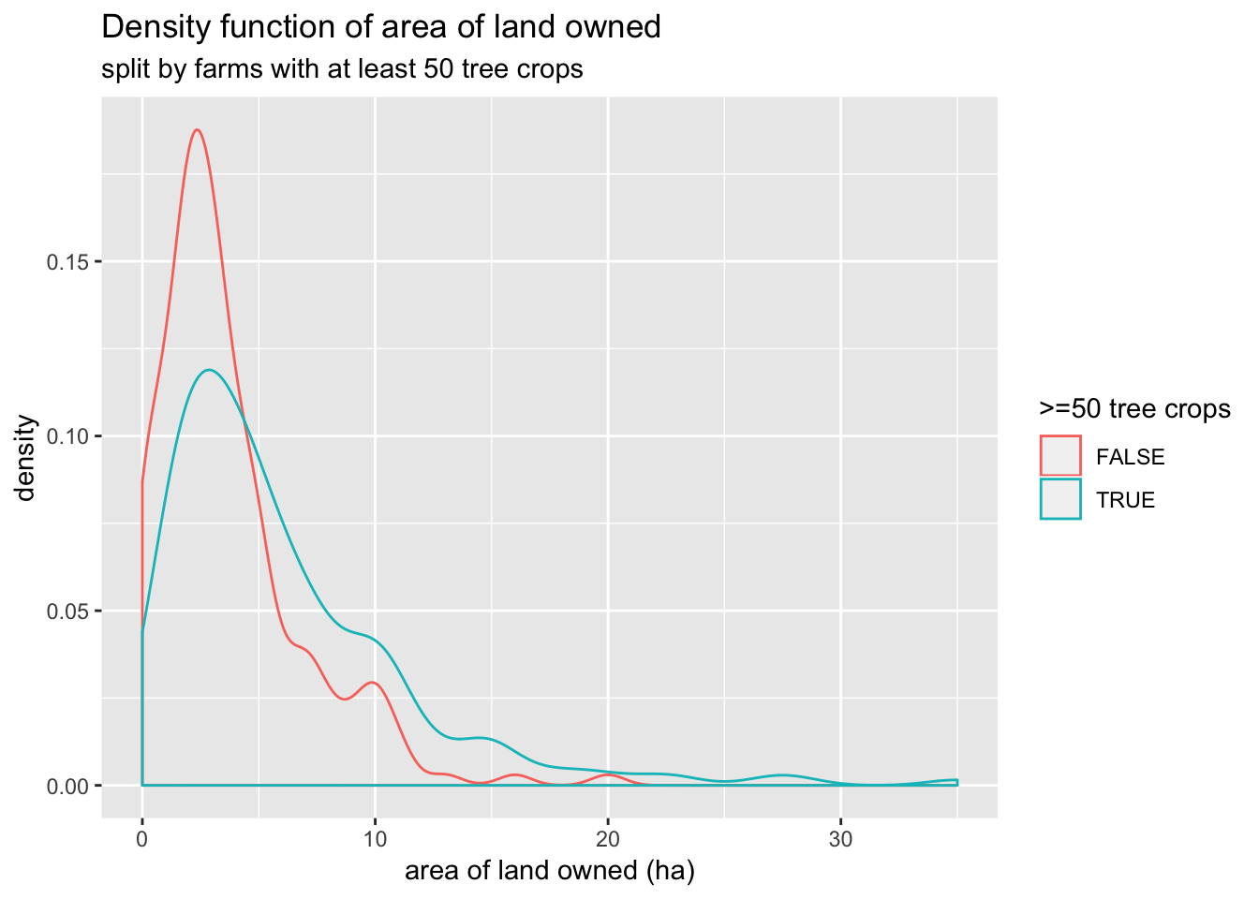
Figure 30: those with more trees tend to have more land and more secure land tenure

Pest and Disease
Far and away the issue that most farmers requested help with was pest and disease (P&D), which are central to understanding the significant concerns and worries that shape farmer decision making amongst the sample. The challenge with regards to the data on P&D is that the farmers may lack the ability to properly identify the diseases – a key finding incorporated into the project via the P&D knowledge exchange and development of a visual pamphlet for cassava P&D identification.
Figure 31: observation of P&D on farm
The survey asked a series of questions about five prominent pests and diseases that affect cassava, including:
- Mealybug
- Witch’s broom
- Bacterial blight
- Mites
- Cassava mosaic disease (CMD)

Farmers were asked if they observed these disease afflicting their cassava during the “last production season” and responses generally had a large number of NA values. The large volume of NA responses makes it difficult to draw much information from the data. For the remainder of this section we make a strong assumption: that all NA responses are “no” responses. The justification for this is that a farmer is likely to have identified a pest or disease if it was having a large impact on their cassava. In a sense we are trying to reinterpret the question as “did you notice this pest or disease having a significant impact on your cassava in the last production season?” This assumption has the potential to seriously corrupt the following analysis, but otherwise we have little to work with. We can try to support this assumption by looking at whether respondents had ever seen the pest or disease, on their or others farms.
The responses to these questions were much clearer, with very few farms giving NA or unsure responses. This suggests that most of respondents were able to identify the pests and disease, supporting the above justification. If respondents were mostly able to identify the pests and diseases, surely they would have noticed them had they been wreaking havoc on their 2016 cassava. Respondents may have given NA responses for observing the pests in 2016 simply because they could not rule out a low level presence. Evidence that this assumption is poor can be found in the 35 (9%) of respondents that reported the presence of a pest or disease, but also estimated no loss as a result of that pest or disease.
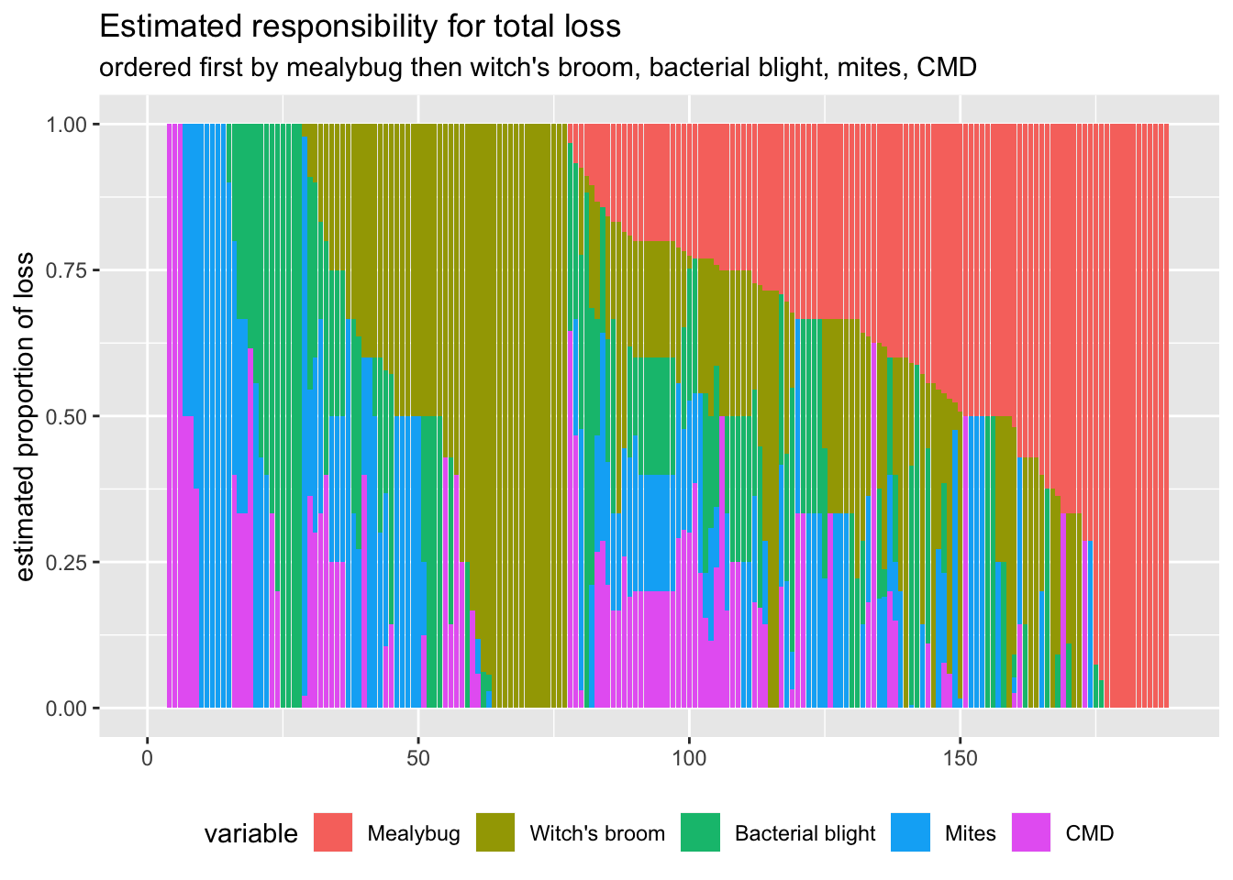
Figure 32: attributed losses to cassava by pest and disease
Another way of visualising this data, which may or may not be clearer, is shown in Figure 32. This plot shows only the 188 farms that farmed cassava in 2017 and completely answered the pest and disease loss questions. Each farm is represented by a vertical column constructed by stacking coloured blocks, each block corresponding to a pest or disease. The length of each of the coloured blocks corresponds to the proportion of responsibility for crop loss attributed to that pest or disease by the given farm. From a glance, mealybug is the most dominant pest. It is important to remain cautious concerning this data, especially given the challenges of P&D identification. Rather than an absolute number of identification of the a specific pest or disease, it is more appropriate to interpret this data as the farmers believing that their crops are being affected by P&D and that they believe those impacts are significant. This belief is evident within the responses concerning actions taken.

Respondents were asked who was primarily responsible for pest and disease control of the cassava crop. The following plot shows the number of times each response was chosen. Respondents were able to select multiple responses, but most chose 1 (199 respondents) or 2 (171 respondents) responses. So a single respondent may have contributed to two or more of the bars. If we look at who is responsible for pest and disease control split by gender of the household head we get plots supporting the idea that the household head is usually primarily responsible, regardless of gender.

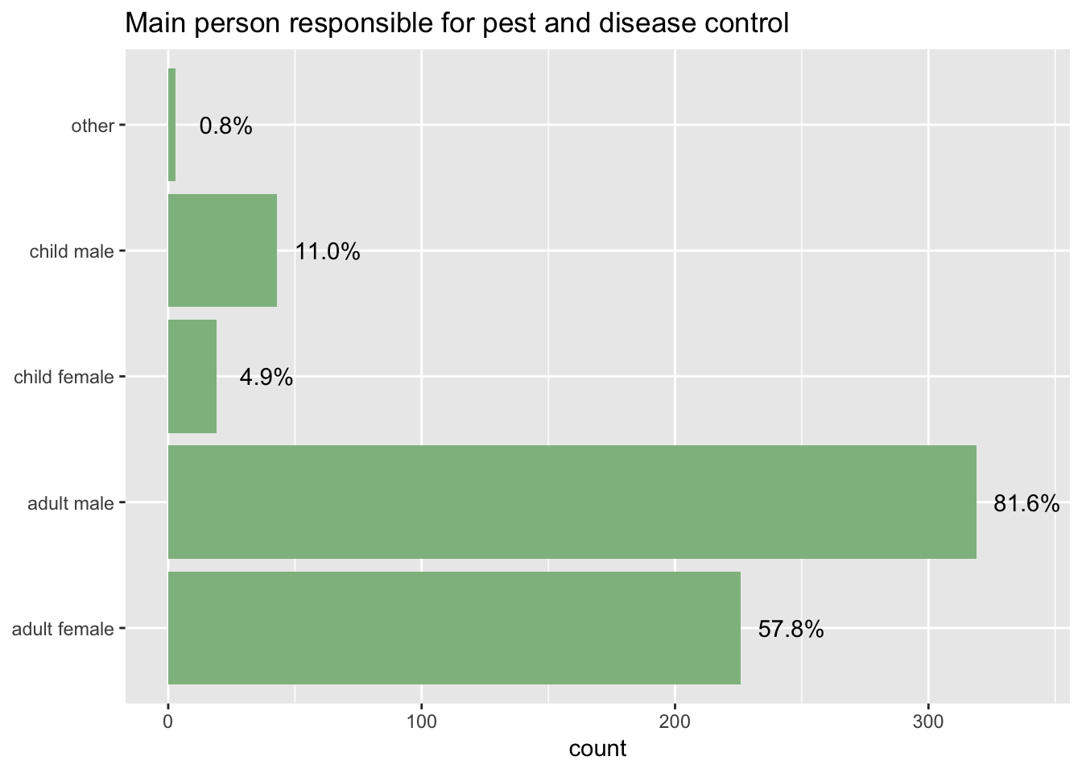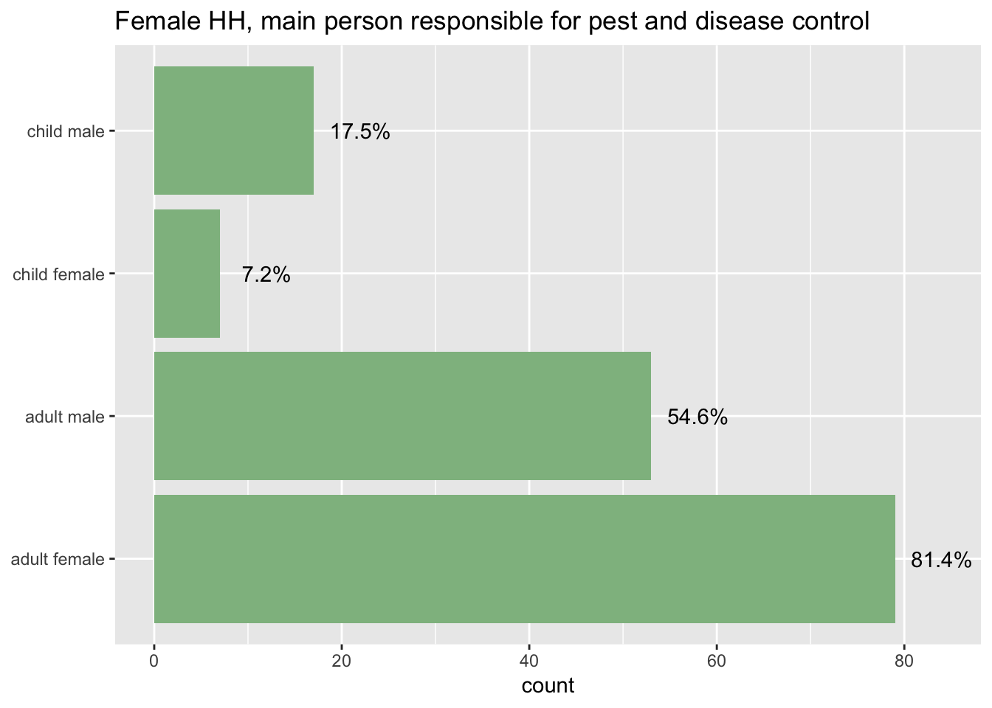
Figure 33 : who is responsible for P&D Figure 34: differences in Female-headed households?
Farmers responded that they tend to monitor for pests and diseases either “every day” or “only when needed”. The image below shows all of the responses, after some simple data cleaning.

Figure 35: frequency of checking for P&D

Gender
A key analytical objective of the research is to explore whether, and ideally how, farmer perceptions and experiences are gendered. This objective is explored in multiple ways, both with regards to the specific – and potentially different – responses from female-headed households, as well as through responses that allocate responsibilities according to gender. We are therefore interested in the characteristics of female head-of-households (HoH) and whether their conditions differ significantly from those of male HoH. In general, we see that female head-of-households (HoH) make up a disproportionate amount of the single and widowed HoHs. Additionally with regards to family composition, household size exhibits more complicated findings. Female HoH farms were proportionally more common amongst smaller household sizes, such as 2 or 3 members, as well as amongst large household sizes, such as 8 and 9. Note that there are relatively few farms with 8-9 members, only 20 farms recorded more than 8 members.

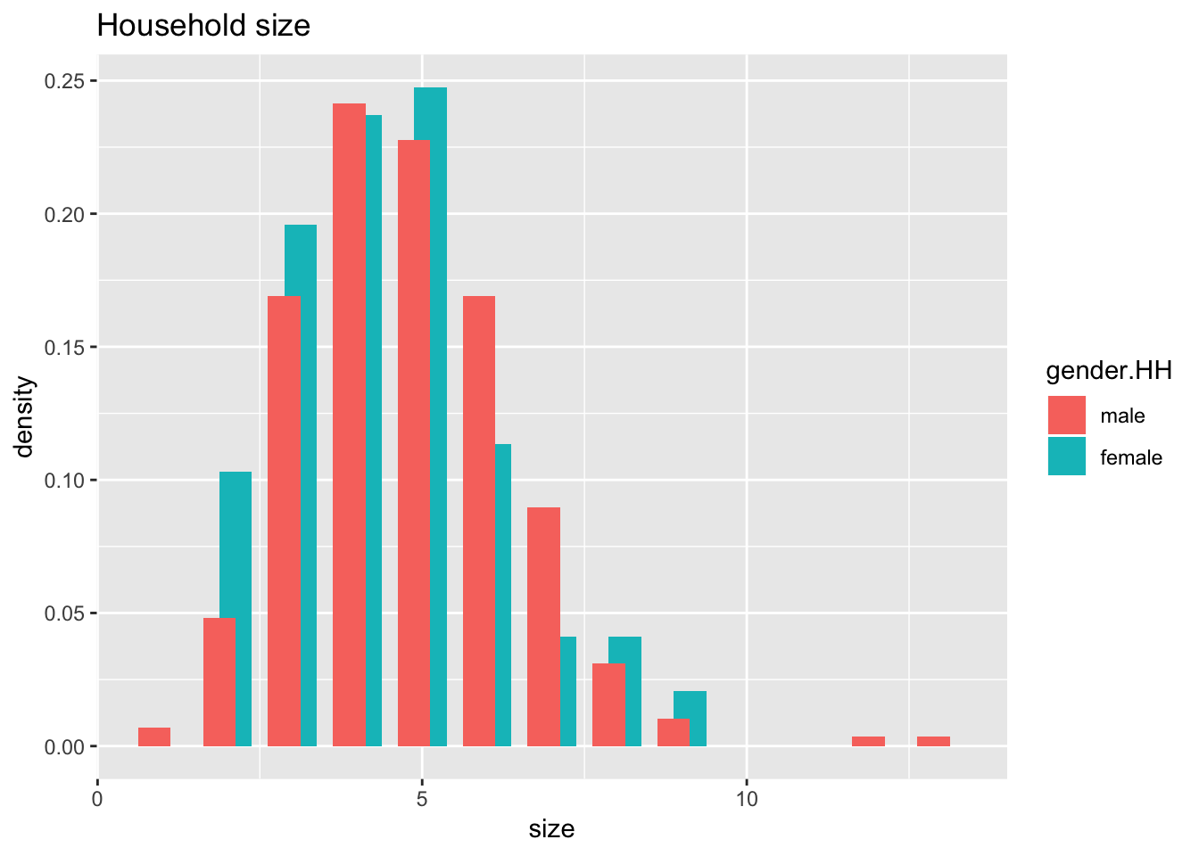
Figure 36: Household size by gender of HoH (note two tails – unknown causes)
Incomes are often presumed to be substantially different between female and male headed households, which is confirmed by the data – but with the caution (from above) in terms of the challenges associated with income data.

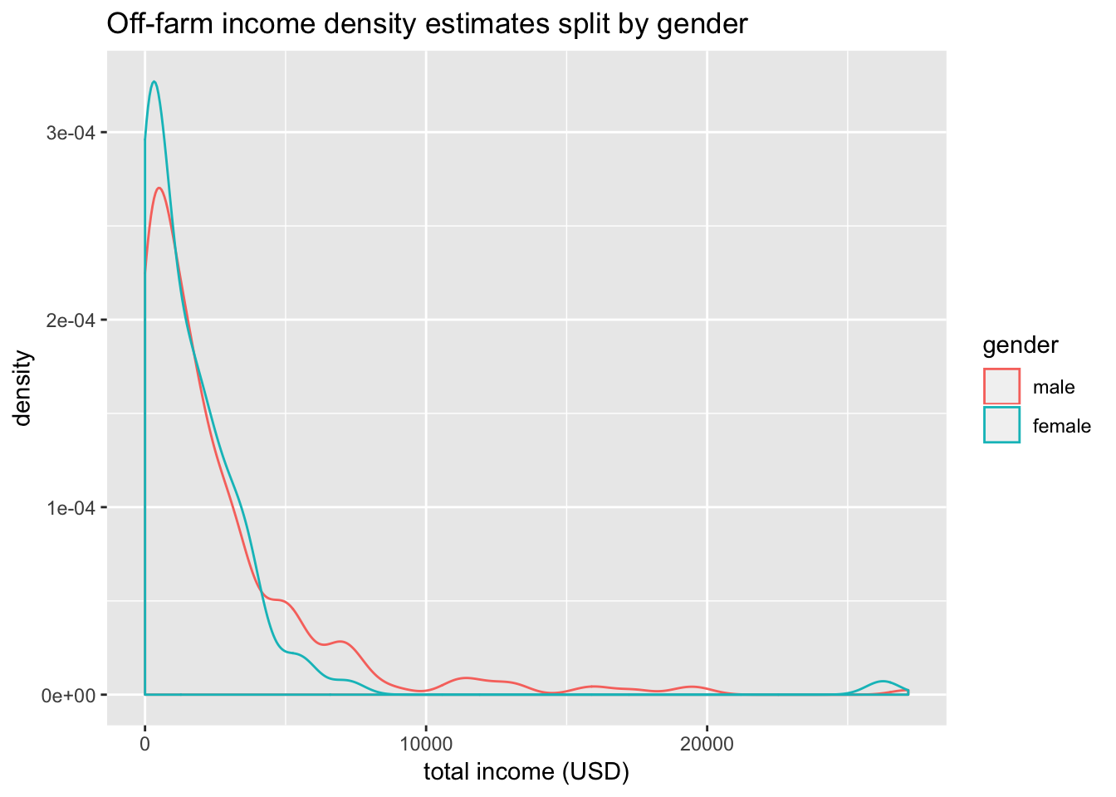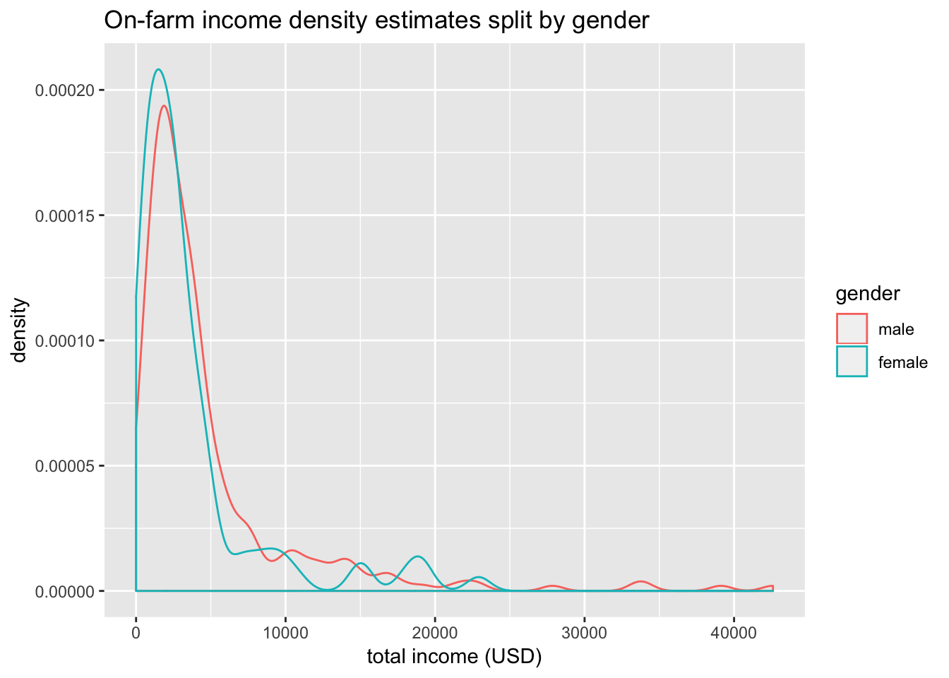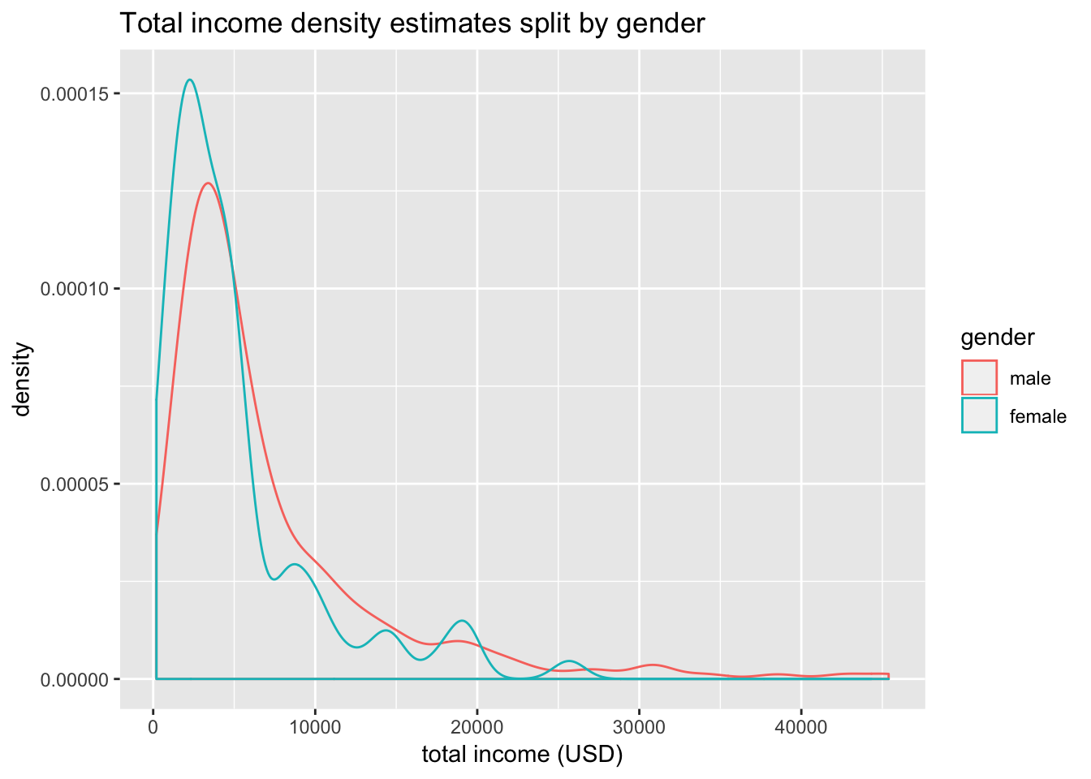
Figure 37: Income by gender, including on/off farm experiences – all suggest female HoH receive less income
Similar to income, the area of land managed by female HoH farms tends to be lower than that of male HoH farms.

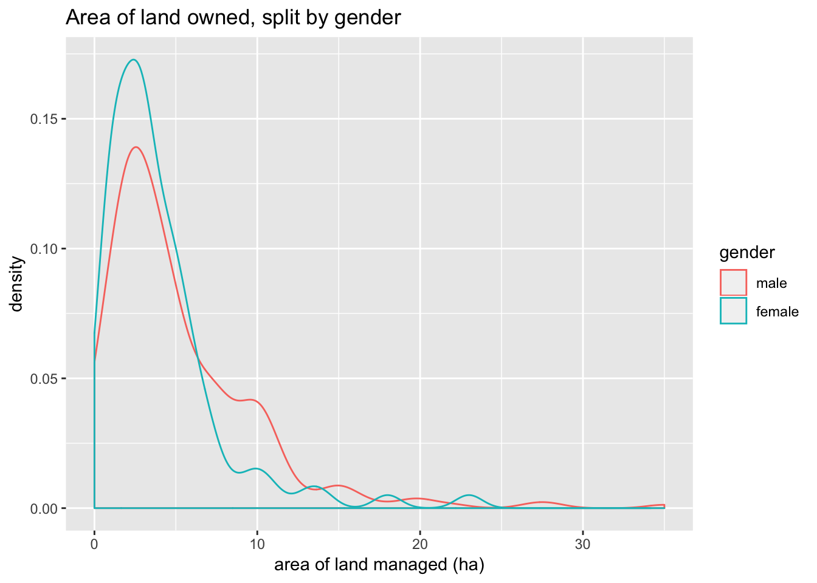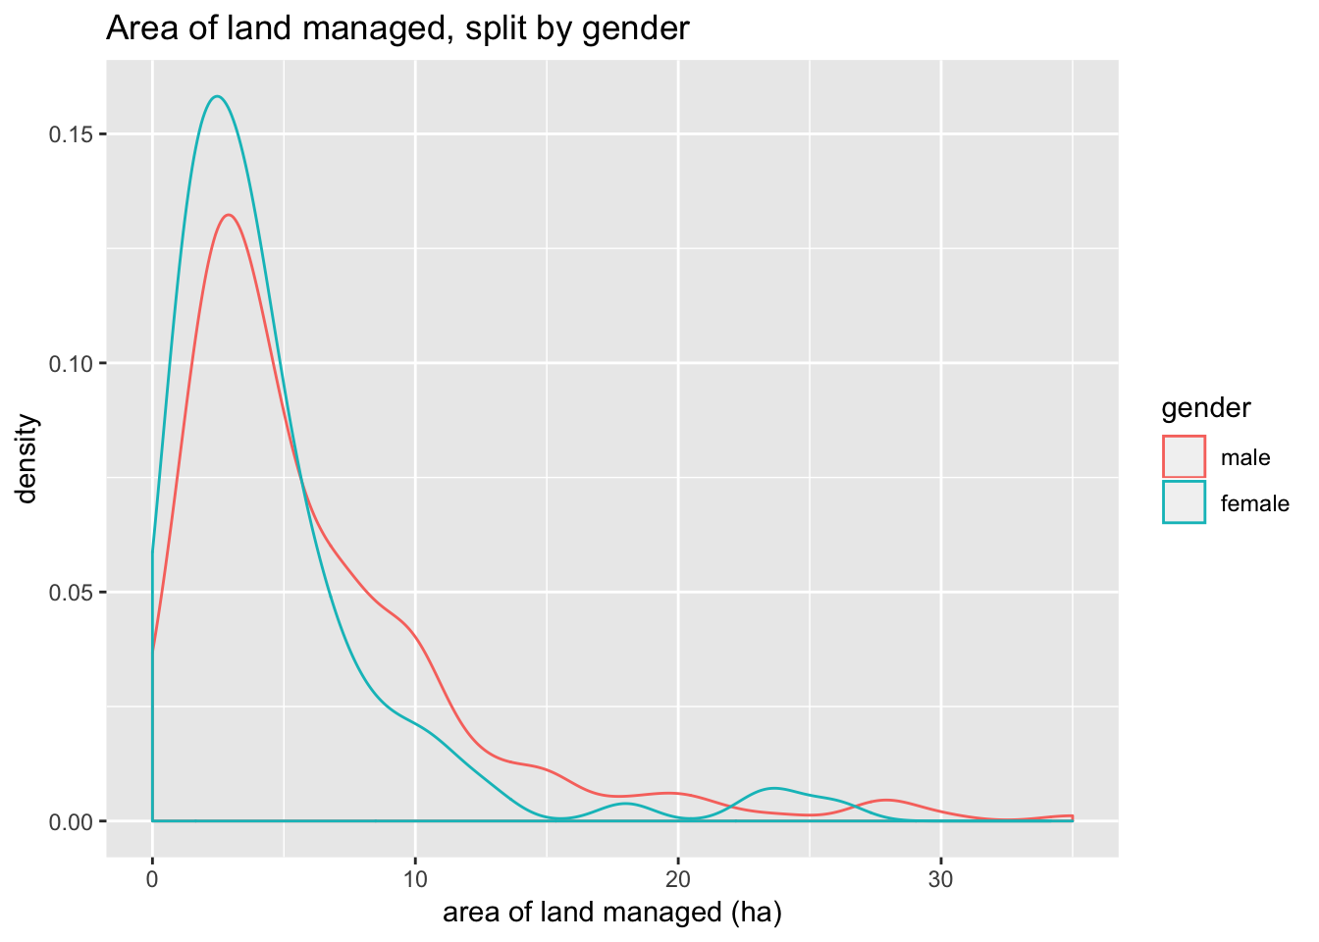
Figure 38: Land and are by gender

Future outlook (Problem-Solution Pathways)
There was a brief section towards the end of the survey that asked respondents about their thoughts on the future. It asked:
- What one change would most improve your life (or your family’s life)?
- How might this change happen?
- Who has the power to make this change?
Respondents generally answered these questions, with only 8 missing answers for the first question, 28 for the second question and 11 for the third question. The responses to all three questions were worded, and we went through classifying responses into broader categories. For all questions the majority of respondents gave a single answer, but some gave two or three. In this analysis we have grouped all these responses together, no weighting was given to respondents that gave multiple answers. In this sense, respondents who gave multiple answers have a larger influence on the results.

What one change would most improve your life?
The first question asked about which single change would most improve the respondents life. Some 10.2% of respondents gave more than one response. The most common response to give was about growing or continuing to grow tree crops, indeed 58.1% of respondents included this answer. It was also common to include responses about high prices (9.2%), growing vegetables (8.2%), opening or maintaining a home business (5.4%) and raising livestock (5.1%). Cumulatively 9% of respondents gave answers about business, or off-farm work while 2% wanted machinery (tractor, truck, or motorbike).

If we break farm households into income brackets, we see that the desire to grow tree crops increases with income (this is also true for total off-farm income). We get similar results if we look at the area of land managed. This is not too surprising, tree crops are a big investment and require time before they produce income. Families need to be able to farm some of the land, or have strong sources of income to support them while they wait for the fruit trees to mature. These differences are supported by a simple test: a Wilcoxon-Mann-Whitney U-test indicates that there is a statistically significant difference in the mean income and mean area of land managed for those who answer “tree crops” compared with those that did not.

How might this change happen?
The second question asked about “how might this change happen?” Some 10.2% of respondents gave more than one response to this question. Most respondents took personal responsibility, 60.1% included “hard work” as a response. Another popular response was “save money”, with 16.6% including it as a response.

Who has the power to make this change?
The third question asked who has the power to make the proposed change. A large number of respondents, 30.4%, gave multiple answers to this question, but most of them were variations on “family”. We created the categories to be as fine as possible, but 80.8% of respondents included one or more of “myself”, “head of household”, “family”, “children”, “grandchildren”, “husband/wife” or “parents”. Only 14.1% of respondents gave answers that included external bodies. There was no significant difference in income or land managed between those who gave a family type response to the third question and those that gave an external body type response.

Conclusion
The data and analysis included in this report is a random sampling of 409 quantitative surveys undertaken in 13 villages in Northwest Cambodia between mid-2017 to late-2017. While the data is, in places, problematic, this is a reflection of the challenges associated with data collection in a very challenging location and of the sensitive nature of the some of the themes.

Key findings
- Farmers indicate that, if given the opportunity, they would transition from cassava production to fruit tree production;
- There is extreme variability in the reported price paid to farmers for cassava – with multiple possible explanations, including: massive variability of prices; and lack of knowledge of prices received; confusion in questioning and response;
- Pest and Disease (P&D) management was the issue that most farmers requested support for;
- There is a relationship between the amount and security of land title and the willingness to plant tree crops;
- The data appears to show two trends amongst farmers transitioning to fruit tree production: 1) those still waiting for their trees to mature, and 2) those receiving income from their fruit trees;
- Income is significantly gendered amongst cassava farming households, both in terms of on-farm and off-farm sources;
- Land assets are significantly gendered amongst cassava farming households;
- Farmers take personal responsibility for their lives and livelihoods, with proposed solutions almost entirely at the individual scale.

Returning to the research questions that guide objective 1 and the baseline survey, the findings of the household survey provide clear answers. With regard to Research Question 1: “What problems do farmers perceive, what do farmers think should be done, what do farmers think can be done by whom (i.e., farmer PSPs)?” the issue of pest and disease (P&D) was the most requested. The farmers communicated to the research team that they were unsure about the types of P&D common to their farms and what, if anything, might be done in response. We expected debt and indebtedness to be a possible problem, and were surprised that the majority of farmers indicated that their levels of debt were manageable – something the project will explore in greater detail using qualitative methods.

With regards to Research Question 2: “Which agricultural technologies do farmers identify as part of their PSPs and why?” the single change that farmers believe would most help them is the transition to fruit tree production, which was, by far, the most identified choice. While this finding is not surprising the scale of this shared objective is striking. The vast majority of elite and wealthy farmers are undertaking this transition and many agricultural experts in the area recommend the transition as superior to cassava. Furthermore, there is a rationality to this desired transition, as fruit trees are more sustainable and, like cassava, require relatively less labour once established when compared to traditional maize-bean rotations.

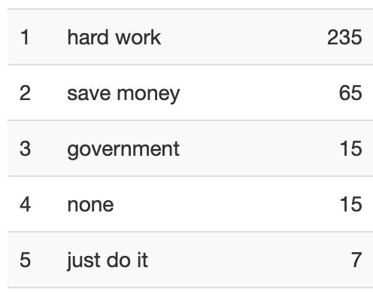
The findings also suggest that perceived and preferred solutions to the problems experienced by farmers are ‘ideally’ addressed at the individual scale via household actions, with only 15 mentioning government – the same proportion of respondents who believe ‘nothing’ can be done to affect change. Specifically, the problems most identified by farmers concern pest and disease, especially the uncertainty with regards to identification and response.
Figure 39: who can implement change?

References
Azam, M. S., Imai, K. S., & Gaiha, R. (2012). Agricultural supply response and smallholders market participation–the case of Cambodia. Kobe, University Japan.
Bateman, M. (2018). Cambodia: the next domino to fall? The Rise and Fall of Global Microcredit (pp. 166-193): Routledge.
Cramb, R., Manivong, V., Newby, J. C., Sothorn, K., & Sibat, P. S. (2016). Alternatives to land grabbing: exploring conditions for smallholder inclusion in agricultural commodity chains in Southeast Asia. The Journal of Peasant Studies, 1-29.
Fleming, A., & Vanclay, F. (2010). Farmer responses to climate change and sustainable agriculture. A review. Agronomy for sustainable development, 30(1), 11-19.
Lamb, V., Schoenberger, L., Middleton, C., & Un, B. (2017). Gendered eviction, protest and recovery: a feminist political ecology engagement with land grabbing in rural Cambodia. The Journal of Peasant Studies, 44(6), 1215-1234.
Le Dang, H., Li, E., Bruwer, J., & Nuberg, I. (2014). Farmers’ perceptions of climate variability and barriers to adaptation: lessons learned from an exploratory study in Vietnam. Mitigation and adaptation strategies for global change, 19(5), 531-548.
Li, T. M. (2014). What is land? Assembling a resource for global investment. Transactions of the Institute of British Geographers, 39(4), 589-602.
Mahanty, S., & Milne, S. (2016). Anatomy of a boom: Cassava as a ‘gateway’crop in Cambodia's north eastern borderland. Asia Pacific Viewpoint, 57(2), 180-193.

Qualitative household interviews are underway, which follow-up on the findings from the quantitative survey in order to add depth and explanation to the preliminary findings.
A finding confirmed in the time following the survey, with widespread transitions underway.

